|  |  |  |
| --- | --- | --- |
| **The islamic University of Gaza**  **Faculty of IT** |  | **الجامعة الإسلامية بغزة**  **كلية تكنولوجيا المعلومات** |

**AI-Powered Market Analysis Study Assistant  
(AI-MAS)**

**مساعد تحليل السوق بتقنية الذكاء الاصطناعي**

**By**

**Laila Iyad Abu Hujaier 220200417**

**Rose Salah Taha 220200271**

**Supervised by**

**Dr. Motaz Saad**

**A graduation project report submitted in partial**

**fulfillment of the requirements for the degree of**

**Bachelor of Information Technology**

**4/2025**

# Abstract

Market analysis is a crucial process for startup founders and entrepreneurs, helping them understand their industry, competitors, and target customers. However, conducting a market analysis can be complex, requiring significant time, expertise, and resources. Many entrepreneurs struggle to gather reliable insights quickly, making it difficult to make informed business decisions. Without an efficient tool, analyzing market size, customer segments, and competitor strategies becomes a challenge. [1]

This project aims to solve this issue by developing a chatbot that assists entrepreneurs in conducting market analysis for their startups. The chatbot allows users to input key business details, such as geographical location, industry sector, and proposed value. Using this information, the chatbot generates insights, including market size, SWOT analysis, competitor analysis, and customer segmentation. By providing real-time, data-driven insights, the chatbot reduces market research time by an estimated 60%, compared to traditional manual methods, saving time spent on data collection and analysis, and report generation. [2]

The chatbot is built using an LLM API integrated with a search engine API. This combination enables real-time data retrieval from the internet, ensuring that market analysis is based on relevant and up to date information. Unlike traditional methods that require manual data collection and expert analysis, this approach allows entrepreneurs to access meaningful insights instantly. The chatbot is designed to be user-friendly and accessible, making market research easier for startups with limited resources.

The chatbot development process follows an iterative prototyping approach, where the chatbot is developed, tested, and refined in cycles to improve its accuracy and usability based on feedback.

This project provides a practical solution for startups, simplifying the market analysis process. By offering real-time insights and reducing the need for extensive research, the chatbot empowers entrepreneurs to navigate their industries with confidence. With this tool, users can make smarter, data-driven decisions, increasing their chances of success in competitive markets.

# ملخص الدراسة

**إنّ نجاح واستمرار أيّ عمل تجاري يعتمد بشكل أساسيّ على التخطيط والمراقبة المستمرة. إعداد خطة أعمال ناجحة لعمل تجاري، يتطلب تخطيطًا استراتيجيًّا وفهمًا عميقًا لعوامل نجاح الأعمال الأساسية، فهي فلسفة منهجية للتعمق في خبايا الفكرة والمشروع، وتحليل سوق المنافسة لاستلهام الأفكار منه والاستفادة من معطياته، وهي أفضل خارطة طريق لإثبات جدوى الفكرة والتحفيز على العمل عليها حتى تغدو واقعًا ملموسًا.  
دراسة تحليل السوق هي إحدى أهم الدراسات لأصحاب الأعمال والشركات قبل الانطلاق في سوق العمل، لتحقيق النجاح في أعمالهم، حيث أن الفهم العميق لحالة السوق يمكّنهم من موائمة أنفسهم هيه والاندماج مع متغيراته. إنّ إجراء دراسة تحليل السوق بالطرق التقليدية يستلزم وصولًا واسعًا للموارد اللازمة، ومهارات البحث والتقرير والتعامل مع الأرقام وفهم متغيرات السوق واحتمالاته واتجاهاته. وكما يواجه الباحثون صعوباتٍ لتجهيز وثائق الأعمال المختلفة، فإن ريادي الأعمال قد يواجهون صعوبات متعددة أثناء إجراء دراسة السوق، يعزى ذلك غالبًا لنقص الخبرة والإرشاد، ومحدودية الوصول للموارد اللازمة. هذه التحديات وغيرها، قد تعوّق قدرتهم على تحليل مستجدات السوق وفهم حالته، وفهم احتياجات العملاء، وسوق المنافسة.** [1]

**يهدف هذا المشروع لتقديم موقع الكتروني يرتكز على خدمات الذكاء الاصطناعي، بتوفير واجهة متحدث ذكي، يقوم من خلال محادثة سلسة وبمدخلات بسيطة من المستخدم بمساعدته في إجراء عملية دراسة السوق، في وقت قياسي، ووصول واسع لكافة ما يلزم من مصادر ومراجع، وتقديم بعض التوجيهات والنصائح لصاحب هذه الفكرة**

# Dedication

All praise and thanks are due to Allah, who guided and supported us in completing our graduation project.

To Gaza, which has taught us the true meaning of resilience and determination, and which deserves our best efforts. It inspired us to bring out the finest within us, and for that, we dedicate this work with love and admiration.

To our righteous martyrs, to your pure souls and to your blood, and to all that you have given.  
To the eternal Heavens.

To our dear parents, who have been our strongest support, surrounding us with their love, patience, and prayers.

To our friends, who never hesitated to offer their encouragement and stood by us, we thank them for every word of motivation and every moment of genuine support.

To our supervisor, Dr. Motaz Saad, who generously provided us with guidance and valuable insights, and who remained a source of inspiration throughout this journey, we express our deepest gratitude and appreciation for his efforts.

To each other, as teammates who worked together toward a shared goal, we appreciate each other’s dedication, patience, and collaboration. Every effort we made brought us closer to success.

# Acknowledgment

First, all praise, gratitude, and thanks are due to Allah, who enabled us to complete this work. Peace and blessing of Him be upon His Messenger Mohammad, who said: ‘He who does not thank people does not thank Allah.’

This project and research would not have been possible without the support and encouragement of many dedicated individuals. We would like to express our appreciation and pray that Allah rewards them on our behalf.

We extend our heartfelt gratitude to our supervisor, Dr. Motaz Saad, for his encouragement, unwavering support, and valuable suggestions that guided us in completing this study and facilitated our progress. We deeply appreciate your belief in us and your efforts in helping us reach this milestone.

We also sincerely thank our families, especially our parents, who stood by us at every step of our academic journey. Their unwavering love and faith in us provided the strength we needed to overcome the challenges of this endeavor.

Finally, we extend our appreciation to our university and our esteemed Faculty of Information Technology at the Islamic University. The knowledge we gained, the experiences we had, and the opportunity to learn from some of the finest experts and academics have been truly invaluable.

Our university remains a beacon of knowledge, and we are honored to be a part of it.

# Table of Contents

Abstract 2

ملخص الدراسة 3

Dedication 4

Acknowledgment 5

Table of Contents 6

List of Tables 10

List of Figures 11

List of Abbreviations 12

Chapter 1 Introduction 1

1.1 Problem Statement 6

1.2 Objectives 6

1.2.1 Main Objective 6

1.2.2 Sub Objectives 7

1.3 Scope and Limitations 7

1.3.1 Scope 7

1.3.2 Limitations 8

1.4 Importance of the project 8

1.5 Background 8

Small and Medium Enterprises (SMEs) 8

Business Planning 9

Market Analysis Study (MAS) 11

SWOT Analysis 12

Porter’s Five Forces Framework 13

Application Programming Interface (API) 14

Artificial Intelligence (AI) 15

Machine Learning (ML) 16

Generative AI (Gen AI) 17

How Generative AI Functions? 17

Nature Language Processing (NLP) 18

Large Language Models (LLMs): 20

Retrieval Augmented Generation (RAG) 20

Benefits of Using RAG 21

Benefits of RAG in the context of market analysis: 22

Important Terms: 22

How Does RAG Work: 22

Comparison Between RAG And Semantic Search: [37] 23

Challenges in Implementing RAG: 24

Chapter 2 Related Works 25

2.1 Related works (websites/platforms) 26

2.2 Key Aspects of Related works in comparison to our work 32

2.3 Summarization and Conclusion 33

Chapter 3 The Prototype Methodology 34

3.1 The Prototyping Methodology 35

3.1.1 Main concepts in prototyping methodology 35

3.1.2 Key Practices and Phases of Prototyping Methodology 36

3.1.3 Types of prototyping in software development 38

3.2 Reasons for adopting the prototyping methodology in our system development 39

3.3 Adaptations and Modifications to the Prototype methodology 40

3.4 Tools and Equipment 41

3.4.1 Tools 41

3.4.2 Equipment 42

3.5 Time Table 42

3.6 Team Management 42

3.6.1 Team Structure and Roles 42

3.6.2 Communication and Collaboration 43

3.6.3 Task Assignment and Timeline 43

3.6.4 Conflict Resolution 44

Chapter 4 Requirements Gathering 45

4.1 Methodology for Requirements Gathering 46

4.2 Functional Requirements for AI-MAS 47

4.3 Non-Functional Requirements for AI-MAS 48

4.4 Challenges and Considerations 49

4.5 System architecture 50

4.6 User Cases 50

4.7 Conclusion 52

Chapter 5 Pre-Development Phase 53

5.1 Problem Definition and System Goals 54

5.2 Literature Review: Understanding Market Analysis and AI’s Role in Business Research 55

5.3 Interfaces and technology Selection 55

5.4 Exploration of RAG 56

Chapter 6 Initial Prototype Development 59

6.1 Selecting the LLM and Search Engine APIs 60

6.2 Testing the Retrieval Process 62

6.3 Evaluating the System's Performance 63

6.4 Conclusion 63

Chapter 7 Design and User Interface 65

7.1 Initial Design Using Gradio 66

7.2 Enhancing Design and User Interactivity 67

Chapter 8 Prototype Development: Testing and Refinement 69

8.1 First Iteration: Initial Prototype Implementation 70

8.2 Second Iteration: Chatbot Interface Integration 71

8.3 Third Iteration: Chat History 71

8.4 System Testing 73

Chapter 9 Experiments 75

9.1 Testing Existing GPTs efficiency to conduct Market Analysis Study: 76

9.1.1 The Instructional Prompt Used for Testing GPT Models (First Testing Prompt) 76

9.1.2 The Instructional Prompt Used for Testing GPT Models (Final testing prompt) 78

9.2 Evaluation of Large Language Models: 81

9.2.1 Testing Different Large Language Models 81

9.2.2 Examples for Extensive, Detailed and Basic answers while testing the models: 83

9.2.3 Final Decision: 84

9.3 Evaluation of Search Engine APIs: 85

9.3.1 Evaluation of Search Engines 85

9.3.2 Final Decision 87

9.4 Prompt Development: 87

9.4.1 The initial prompt: A simple market analyst role: 87

9.4.2 Second Prompt: Defining Key Business Components 89

9.4.3 Third Prompt: Introducing a Structured Output Format 92

9.4.4 Final Prompt Refinement: Enhancing the Flow, Tone, and User Experience 95

Chapter 10 Use Cases and System Execution 98

10.1 Makkah Restaurant Market Analysis 99

10.2 Business Templates-Qatar Market Analysis 101

10.3 New York Clothing shop Market Analysis 103

10.4 Gaza Tents Market Analysis 106

Chapter 11 Conclusions and Future Works 108

11.1 Conclusion 109

11.2 Future Works 109

References 111

# List of Tables

Table 1: Comparison between RAG and Semantic Search 23

Table 2: The Key Aspects of Each Platform/Paper 32

Table 3: Functional and Non-Functional Requirements Priority Criteria 47

Table 4: Functional Requirements for AI-MAS 47

Table 5: Non-Functional Requirements for AI-MAS 48

Table 6: Prototype Development Iterations Summary 70

Table 7: GPTs Testing Criteria for the Initial Testing Prompt 77

Table 8 : Evaluation of GPT Models' Performance for Market Analysis Tasks - First Testing Prompt 77

Table 9: GPTs Testing Criteria for the Final Testing Prompt 80

Table 10: Evaluation of GPT Models' Performance for Market Analysis Tasks - Final Testing Prompt 80

Table 11: LLM APIs Evaluation Criteria 81

Table 12: LLM APIs Evaluation 82

Table 13: Answer Depth Levels of Different Models 83

Table 14: SE APIs Evaluation Criteria 85

Table 15: Search Engine APIs Evaluation 85

# List of Figures

Figure (1): Business Model Canvas [19] 10

Figure (2): SWOT Analysis Template [21] 12

Figure (3): Porter's five Forces [23] 13

Figure (4): API [25] 15

Figure (5): Natural Language Processing [32] 19

Figure (6): RAG Technology [34] 21

Figure (7): IBISWorld - US Furniture use case report - pt 1 26

Figure (8): IBISWorld - US Furniture use case report - pt 2 27

Figure (9): Eur. Int. - Retail and e-Commerce Market in the US use case overview 28

Figure (10): Map.ai - Market Analysis Insights for A Coffeeshop In New York 29

Figure (11): Map.ai - Competitor Analysis for A Coffeeshop In New York 29

Figure (12): Map.ai - SWOT Analysis for A Coffeeshop In New York 29

Figure (13): VenturusAI - Emirati Elegance Clothing Brand Market Analysis– pt 1 30

Figure (14): VenturusAI - Emirati Elegance Clothing Brand Market Analysis -pt 2 31

Figure (15): VenturusAI - Emirati Elegance Clothing Brand SWOT Analysis 31

Figure (16): VenturusAI - Emirati Elegance Clothing Brand PESTEL Analysis 31

Figure (17): Prototype Methodology 37

Figure (18): Time Table 42

Figure (19): System Architecture 50

Figure (20): Main Use Case 51

Figure (21): Request Edit Use Case 51

Figure (22): Connection to Bing Search Engine 60

Figure (23): Bing Connection Code Terminal 61

Figure (24): Falcon Connection Code Terminal 61

Figure (25): Falcon to Bing Integration Terminal 62

Figure (26): First Gradio Interface 67

Figure (27): Final Prototype Gradio Interface 68

Figure (28): Convert Chat History into The Format Expected by The Model 72

Figure (29): Sending Formatted Conversation to The Model for Processing 72

Figure (30): Performing Bing Search on User’s Inputs 73

Figure (36): Instructional Prompt for Testing GPT Models (First Testing Prompt) 76

Figure (37): Instructional Prompt for Testing GPT Models (Final Testing Prompt) 79

Figure (38): Llama 3 8B Response Issues – pt 1 84

Figure (39): Llama 3 8B Response Issues – pt 2 84

Figure (40): Chatbot Conversation with Initial Prompt 89

Figure (41): Chatbot Example – Second Structured prompt Development 92

Figure (42): Chatbot Example - Third Structured Prompt Development 94

Figure (43): Chatbot Example - Final Structured prompt Development 97

# List of Abbreviations

|  |  |
| --- | --- |
| AI | Artificial Intelligence |
| API | Application Programming Interface |
| BMC | Business Model Canvas |
| BoW | Bag of Words |
| CSS | Cascading Style Sheets |
| GCS | Google Custom Search |
| GPT | Generative Pre-trained Transformer |
| GPU | Graphics Processing Unit |
| GUI | Graphical User Interface |
| HTML | Hypertext Markup Language |
| IDE | [Integrated development environment](https://en.wikipedia.org/wiki/Integrated_development_environment) |
| IT | Information Technology |
| LLM | Large Language Model |
| MAS | Market Analysis Study |
| ML | Machine Learning |
| MVP | Minimum Viable Product |
| NLP | Natural Language Processing |
| PDF | Portable Document Format |
| PHP | Hypertext Preprocessor, previously was abbreviated as: Personal Home Page |
| pt | Part |
| RAG | Retrieval Augmented Processing |
| RLHF | Reinforcement Learning with Human Feedback |
| SE | Search Engine |
| SWOT | Strengths, Weaknesses, Opportunities, and Threats |
| TF-IDF | Term Frequency-Inverse Document Frequency |
| UI | User Interface |

# Chapter 1 Introduction

**Chapter 1  
Introduction**

Just as a tree grows from a seed, a business grows from an idea. Great businesses begin with great ideas and thrive through effective planning [3]. Strategic planning is the foundation of a successful business; it bridges the gap between where you are and where you aim to be by defining what actions to take, and how and when to implement them.

For startups, business planning is crucial. It involves studying the feasibility of an idea, conducting SWOT analysis, developing business models and business plans, and understanding the target market. Effective planning reduces risks, aligns team efforts, and improves the chances of long-term success. Studies reveal that Entrepreneurs who write formal plans are 16% more likely to achieve viability than the otherwise identical non-planning entrepreneurs. [4]

Strategic planning serves as a fundamental pillar for startup success, providing a structured approach to navigating challenges such as limited resources, market competition, and financial constraints. Empirical data underscores the critical role of planning in business sustainability. Researches indicate that approximately 30% of new small businesses fail by the end of their second year, while about 50% fail before reaching their fifth year [5]. A comprehensive study by CB Insights analyzing 242 startup failures found that 42% failed due to a lack of market demand, 29% ran out of cash, and 17% collapsed due to the absence of a sustainable business model, which are challenges that could have been mitigated through robust planning and strategic foresight [6]. Without a robust business plan, which is a strategic document outlining a company's goals, target market, financial projections, and operational strategy, startups often struggle to adapt to market dynamics, secure funding, and attract investors, ultimately undermining their viability in an increasingly competitive business landscape.

Conversely, the absence of a well-defined business strategy significantly reduces a startup’s ability to establish a market presence, achieve financial stability, and long-term sustainability.   
One notable case is Airbnb, whose initial business plan has helped them identify their target market and scale to global success [7]. A well-structured business plan not only defines clear objectives and risk mitigation strategies but also enhances decision-making processes and increases the likelihood of securing external investment.

One of the most critical plans for startups is market analysis study, sometimes referred to as market research [8], this analysis requires detailed research on the targeted market to test its feasibility. While a feasibility study conducted at the initial phases of a business development measures the viability of the business idea, the market analysis study assesses the feasibility of a specific market determined by the business owners.

A market researcher must first define the target market based on several factors: geographical location, sector or industry, and specific age groups or societal segments. Next, the proposed value of the business must be determined, the proposed value is what differentiates the business from competitors. Additionally, the analysis should outline the potential competitors in the market.

Traditional market analysis methods, while effective, are often constrained by their reliance on manual data collection and human analysis. These processes typically result in limited data coverage, as they depend on predefined samples and human effort. Additionally, the time required to gather, process, and interpret the data can slow decision-making, reducing a business's ability to respond to dynamic market conditions. [9]

To address these challenges and provide startups with faster, more efficient market analysis, we propose our project, the AI Market Analysis Study Assistant Platform (AI-MAS).

In today's rapidly changing business landscape, traditional methods may no longer provide the real-time insights needed to make informed decisions. As technology continues to advance, new tools and software have emerged that can automate data collection and analysis, providing a more comprehensive understanding of market trends and consumer behavior in a fraction of the time. These modern methods allow for real-time data updates and trend analysis, enabling businesses to make more informed decisions quickly, responding efficiently to dynamic market conditions. By incorporating these tools into their strategies, companies can stay ahead of the competition and adapt to market changes more effectively.

In recent years, technological advancements have completely changed the way market studies are carried out. With the rise of data analytics tools, businesses can process large datasets quickly and extract valuable insights that would have taken months of tough work or even been impossible with traditional methods. Another significant advancement is the ability of using APIs to collect real-time data, integrate with external platforms and applications, such web search engines, and social media platforms; this enables business to react swiftly to changes by providing them with up-to-date market data and conditions, within reasonable time.

One important advancement in technology is Artificial Intelligence (AI), which can be characterized by machines capable of not only mimicking human intelligence and behavior, but also autonomously generating effective solutions, and rationally responding to conditions.  
With the growing need for faster, data-driven decision-making and problem-solving, AI has become a transformative force in modern business strategies. AI-powered tools and technologies automate complex processes, analyze massive datasets to uncover real-time, actionable insights, and identify emerging trends. These capabilities provide businesses with significant competitive advantage, enabling them to respond smoothly to changing market dynamics. By enhancing decision-making and improving operational efficiency, AI empowers organizations to achieve performance levels that traditional methods cannot match.

Generative Artificial Intelligence (Gen AI) [10], represents a transformative leap in the field of AI, promising with a new era of innovation, creativity, and autonomy. Unlike traditional Descriptive AI systems that rely on preprogrammed rules and algorithms, Gen AI possesses the remarkable ability to generate new ideas, solutions, and innovations autonomously, mimicking human creativity and ingenuity.   
Generative models are at the heart of Gen AI, considered as a class of machine learning algorithms that learn from vast amounts of data, called training datasets, to create new content, including images, text, voice, and even entire virtual worlds. can generate highly realistic and novel outputs that are in most cases, indistinguishable from human-created content. [11]

One of the most impactful applications of Gen AI is the development of chatbots. Chatbots are AI-powered applications that are designed to interact with users in a fluent natural language, providing information, answering questions, and solving problems, assisting with daily task, they also can engage in meaningful conversations, and even provide personalized recommendations, making them invaluable tools in business, customer service, and market analysis.   
Chatbots have evolved significantly with the advent of Large Language Models (LLMs). LLMs such as the GPTs applications, which gained widespread recognition since the end of the last decade. LLMs are trained on vast amounts of structured and semi-structured data, enabling them to understand and respond with human-like responses across a wide range of topics.

The integration of AI and its applications into business decision-making has proven to significantly enhance operational efficiency, decision accuracy, and overall business performance.   
AI tools analyze data 100 times faster than traditional methods, providing deeper insights. AI-powered chatbots are cutting response times by 60%, helping businesses adapt quickly to market changes. [2]

AI has significantly improved marketing analytics by analyzing customer preferences and behavioral patterns, allowing businesses to refine their marketing strategies. The rise of AI-powered predictive analytics has enhanced decision-making, enabling marketers to anticipate trends, recognize opportunities, and optimize campaigns. Personalized marketing has become more precise, as AI allows businesses to analyze individual behaviors and deliver highly targeted content tailored to consumer expectations. Additionally, automating repetitive marketing tasks, such as email campaigns and social media management, has improved efficiency and allowed marketers to focus on strategic planning.  
AI has become indispensable in modern marketing, equipping businesses with real-time decision-making capabilities that enhance campaign effectiveness. Its widespread adoption across marketing platforms has made AI tools accessible to organizations of all sizes. The proven benefits of AI in marketing have further solidified its role as a valuable asset, driving broader industry adoption. As AI continues to evolve through ongoing research and development, its impact on marketing strategies remains substantial, positioning it as a transformative force shaping the future of marketing.

Many applications in the existing market provide services facilitating the market analysis study, and many writers and researchers have produced research papers and articles discussing the importance of integrating AI applications in business and planning. Wordkraft AI [12] and Statista [13] are examples of AI-driven websites that provide market insights for a targeted market and proposed service/value. FounderPal's SWOT Analysis Generator [14] offers SWOT analysis services for business ideas and markets, and DimeADozen.ai [15] analyzes business ideas and provides comprehensive business reports. There are also studies that confirm the transformative role of AI in enhancing market analysis and decision-making processes, such as Wang's and Zhang's study [16] and Felipe A. Csaszar’s study [17].

Our service differentiates itself by combining real-time data retrieval through integration with a search engine API and an LLM API, enabling users to access up-to-date information. This includes customized analyses for niche sectors, a conversational chatbot interface for user-friendly interaction, and the ability to generate SWOT analysis, marketing, and competitor insights in a single platform.

The primary goal of this project is to simplify the process of conducting market research by leveraging broad, up-to-date internet resources tailored to the user’s specific needs. Through a conversational chatbot interface, users can easily share details about their target market and proposed value. The chatbot then delivers key insights, including market size estimation, SWOT analysis, customer segmentation, and competitor analysis.

Our platform reduces the effort required to manually search for information across multiple websites. Instead of redirecting users to various sources, it consolidates the most relevant data into concise, actionable insights, simplifying the entire research process.

## 1.1 Problem Statement

One critical business plan for entrepreneurs and startups pursuing business success is Market Study Analysis, helping them not only to understand the market but also to test the market potentiality of their businesses. Understanding the market is crucial for startups and entrepreneurs seeking to build sustainable and successful businesses. It provides insights into market trends, customer needs, and competitive dynamics, helping businesses to fit themselves in the competitive market, adapt, and grow efficiently. However, traditional methods of conducting market analysis often pose some challenges. These include limited access to resources and tools, lack of experience, and the time-consuming process of gathering and evaluating large volumes of data. As a result, many startups usually struggle to analyze market trends effectively, identify customer needs, and assess competition, hindering their ability to make informed decisions and achieve economic growth.

Several existing companies and platforms, have developed solutions to address these challenges by offering market research tools, competitive analysis, and data-driven insights. However, these solutions are often costly, complex, or require specialized expertise, making them less accessible to early-stage startups with limited resources and experience. In addition to that most of them are typically providing results focused on specific types of studies, such as SWOT, which may not fully meet the needs of entrepreneurs seeking a comprehensive and integrated market analysis, making them less accessible to early-stage startups with limited resources and experience.

## 1.2 Objectives

### 1.2.1 Main Objective

The main objective of this application is to simplify the process of conducting market research studies for users, saving them time, money, and effort. This is achieved by delivering meaningful insights about market size and trends, brief competitor analysis, and SWOT analysis. This happens through a smooth and user-friendly chat interaction, allowing users to input their information easily and receive relevant market insights instantly. The chatbot ensures a seamless experience, making market research more accessible and efficient.

### 1.2.2 Sub Objectives

sub goals that contribute to achieve the main goal are: 

* Defining the project's scope, functionalities, and technical tools. Also learning and getting familiar with these tools.
* Setting up a Python development environment to connect to the LLM API.
* Leveraging search engines to supply the LLM with real-time and up-to-date information.
* Integrating a search engine API with the LLM API.
* Selecting the best search engine and LLM based on performance, accuracy, and cost-effectiveness.
* Developing a chatbot interface using the Gradio framework to facilitate user interaction.
* Establishing a predefined query format and a market analysis study structure “prompt” to improve user input processing and response accuracy.
* Providing the model with an appropriate response format that aligns with market analysis requirements.

## 1.3 [Scope](http://www.cs.stir.ac.uk/~kjt/research/conformed.html) and Limitations

### 1.3.1 Scope

* Our project focuses on developing a chatbot designed to help users to conduct their market analysis for their startups.
* The chatbot accepts user input, including geographical location, sector, business model, and customer segment, to generate actionable insights.
* Outputs include market size, marketing strategies, SWOT analysis, customer segments and brief competitor analysis.
* The system leverages pre-trained language models through LLM APIs and search engine APIs for real-time data retrieval.
* The chatbot is deployed using the Gradio platform and hosted locally through the development process.
* The chatbot operates based on real-time data retrieval from the web, through APIs and its inherent capabilities.

### 1.3.2 Limitations

* The chatbot will not involve fine-tuning or training new or existing models; it will rely entirely on API integrations with existing pre-trained LLMs.
* API usage may be restricted by the number of calls allowed under the service plans. More details are explained later in chapter 9.
* No custom knowledge base for data retrieval to be provided.
* Real-time data retrieval depends on the availability and accuracy of web resources accessed through the search engine APIs.
* The chatbot’s performance and accuracy are influenced by the capabilities of the APIs and the quality and the detailed level of input provided by users.
* Internet connectivity may affect the system’s availability.

## 1.4 Importance of the project

Our project provides an advanced and effective tool to facilitate carrying out market analysis studies for startups. Conducting a market analysis study adopting the traditional approaches can be time-consuming and resource-intensive, but our chatbot simplifies the process by providing real-time, relevant insights. It provides a cost-effective alternative for entrepreneurs and small businesses that may lack the resources to hire professional analysts or afford costs of traditionally performing their market analysis. By leveraging advanced Search Engines API and pre-trained LLMs API, the platform ensures that even Users without technical and planning expertise can get beneficial market insights through a user-friendly interface. It empowers users to make informed decisions by providing valuable insights, such as SWOT analysis, market size estimates, competitor analysis, risk reduction and enabling strategic decisions for startups.

## 1.5 Background

This section introduces key concepts related to the development of a chatbot for market analysis in our project. These definitions will help non-technical readers understand the project's purpose and functionality. Familiar readers may skip it.

### Small and Medium Enterprises (SMEs)

SMEs are small to medium enterprises, which usually employ fewer than 250 employees, this threshold can vary by region or industry. SMEs are crucial to global economies, driving growth, employment, and innovation. Despite their small size, SMEs excel in flexibility and entrepreneurship.

### Business Planning

Business planning serves as the foundation of any successful enterprise, offering a structured approach to decision-making, resource allocation, goal-setting, and business monitoring. It ensures that a startup develops a viable model before committing resources by clarifying key elements such as value proposition, customer segmentation, and revenue streams. For instance, a tech startup developing a mobile payment app must define its target users (e.g., small businesses, freelancers, or large enterprises), determine its pricing model (subscription-based, transaction fees, or freemium), and assess potential revenue sources (subscriptions, advertisements, partnerships, or premium features). A well-structured business plan aligns a company’s internal capabilities, such as technical expertise, operational efficiency, and available capital, with external market opportunities, mitigating risks and enhancing long-term sustainability. [18]

Without a clear plan, businesses often struggle to secure funding from investors, navigate competitive pressures, and scale efficiently in saturated markets.  
Entrepreneurs who adopt a systematic approach to business planning improve their chances of success by identifying potential challenges early and formulating strategic responses. Effective planning involves scenario analysis, competitive positioning, and financial forecasting, enabling startups to adapt to shifting market conditions. Utilizing established frameworks such as the Business Model Canvas allows startups to visualize key components of their business model as the figure 1 below shows, while SWOT analysis helps identify internal strengths and weaknesses, and external opportunities and threats.

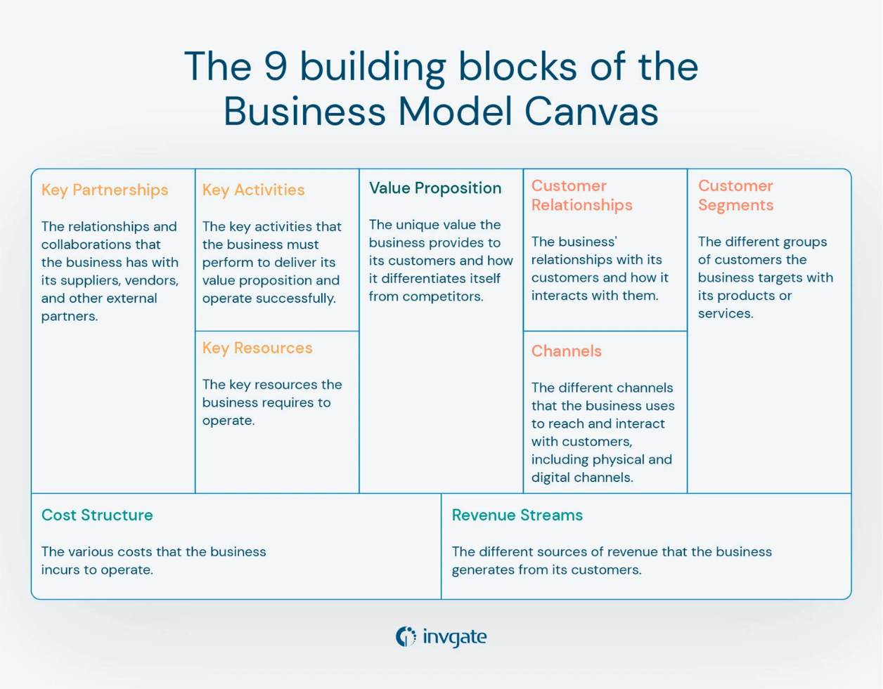

Figure (): Business Model Canvas [19]

Additionally, continuous business planning ensures that startups remain adaptable in rapidly evolving industries. Modern businesses rely on data analytics and AI-driven insights to refine their market strategies. A well-crafted business plan also plays a crucial role in securing external funding. Investors and venture capitalists assess business plans to determine whether a startup has a clear growth strategy, a sustainable revenue model, and a competitive advantage. Entrepreneurs who present data-driven market insights, well-structured financial projections, and clearly defined milestones increase their chances of securing investments. For instance, fintech startups seeking seed funding often highlight user acquisition metrics, projected transaction volumes, and strategic partnerships with financial institutions to demonstrate scalability and market potential.   
Ultimately, business planning is not a one-time exercise but an ongoing process that evolves as business and market conditions change. Startups that regularly update their strategies based on real-time data, competitor movements, and consumer trends can make informed adjustments to stay ahead. By integrating structured planning, strategic foresight, and data-driven decision-making, businesses enhance their resilience, improve operational efficiency, and maximize their chances of long-term success.

### Market Analysis Study (MAS)

Market analysis is a crucial process that enables businesses to assess industry conditions, competition, and consumer behavior. It provides valuable insights that help businesses identify opportunities, mitigate risks, and develop effective strategies. Four key areas form the foundation of market analysis:

* **SWOT Analysis:** SWOT analysis is a structured method for evaluating a business’s internal strengths and weaknesses, along with external opportunities and threats. It helps businesses understand their position in the market and make informed strategic decisions. A detailed explanation of SWOT analysis is provided in the next section.
* **Competitor Analysis:** Understanding competitors is essential for businesses to refine their strategies and improve market positioning. Competitor analysis involves identifying direct and indirect competitors, assessing their product offerings, pricing strategies, market reach, and competitive advantages. This process helps businesses identify market gaps, anticipate threats, and develop strategies to differentiate themselves. One common framework used for competitor analysis is Porter’s Five Forces, which evaluates factors such as the threat of new entrants, bargaining power of suppliers and buyers, competitive rivalry, and the influence of substitute products. More details about Porter’s Five Forces Framework are provided in a separate section. By analyzing these elements, businesses can adjust their pricing, improve their products, and enhance their marketing strategies to gain a competitive edge.
* **Market Trends:** Market trends indicate shifts in industry dynamics, technological advancements, and changing consumer needs. Tracking trends helps businesses anticipate demand fluctuations, identify emerging opportunities, and avoid obsolescence. Using real-time data and predictive analytics allows businesses to adapt quickly to changes in market demand.
* **Customer Segments:** Identifying and analyzing customer segments enables businesses to target the right audience with tailored products and services. Segmentation is typically based on demographic, geographic, behavioral, and psychographic factors. Demographic segmentation includes variables such as age, gender, income, and education level. Geographic segmentation considers location-based preferences, while behavioral segmentation focuses on purchasing habits, brand loyalty, and usage patterns. Psychographic segmentation examines lifestyle, interests, and values. By defining customer segments, businesses can develop personalized marketing strategies, optimize pricing, and improve customer engagement, ensuring their products or services align with consumer expectations.

These core areas provide businesses with essential insights needed to navigate competitive markets, make data-driven decisions, and enhance their overall market strategy.

### SWOT Analysis

SWOT analysis is a well-known strategic planning tool to assess an organization's internal strengths and weaknesses along with external opportunities and threats that an organization may face. SWOT is an analysis process that involves four areas into two dimensions. It has four components: Strengths, Weaknesses, Opportunities, Threats. The factors of strengths and weaknesses relate to the internal dimension, Threats and opportunities are external one. Below, figure 2 shows a template that guides the process of conducting a SWOT analysis, and what aspects to carry out in each area. [20]

In market analysis, SWOT provides a framework that details the current business standing.

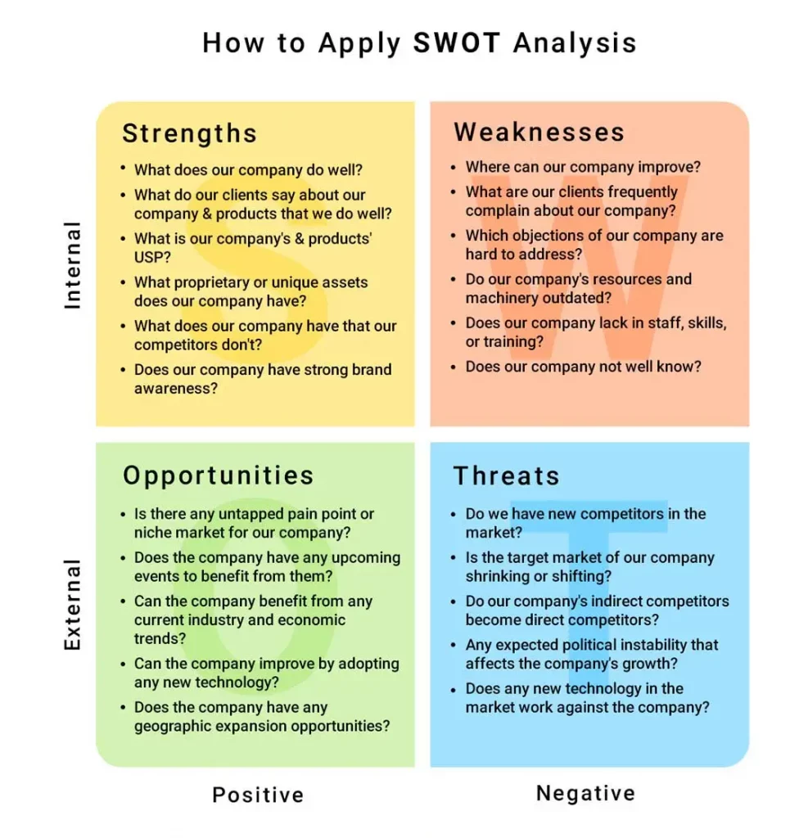

Figure (): SWOT Analysis Template [21]

Strengths are the internal attributes or resources that give a company a competitive edge, such as a strong brand reputation, unique products, operational efficiency, or access to skilled labor. Weaknesses, on the other hand, are internal limitations that hinder performance, such as outdated technology, insufficient funding, or poor market presence. Opportunities are external factors that a business can capitalize on, such as emerging market trends, technological advancements, or changes in consumer behavior that align with the company’s offerings. Lastly, Threats are external challenges that could negatively impact the business, such as economic instability, regulatory changes, or strong competition. Conducting a SWOT analysis helps businesses gain insights into their market position, refine strategies, and make informed decisions to maximize opportunities while minimizing risks.

### Porter’s Five Forces Framework

Michael E. Porter's Five Forces model is a widely respected framework in business strategy, offering a powerful tool for analyzing and adapting to market dynamics. As figure 3 shows, the model identifies five key forces that shape competition within an industry: the level of internal competition among existing firms, the threat of new entrants, the bargaining power of suppliers, the bargaining power of customers, and the availability of substitute products or services. Understanding these forces allows businesses to assess the competitive pressure within their industry and develop strategic responses to maintain or improve their market position. [22]

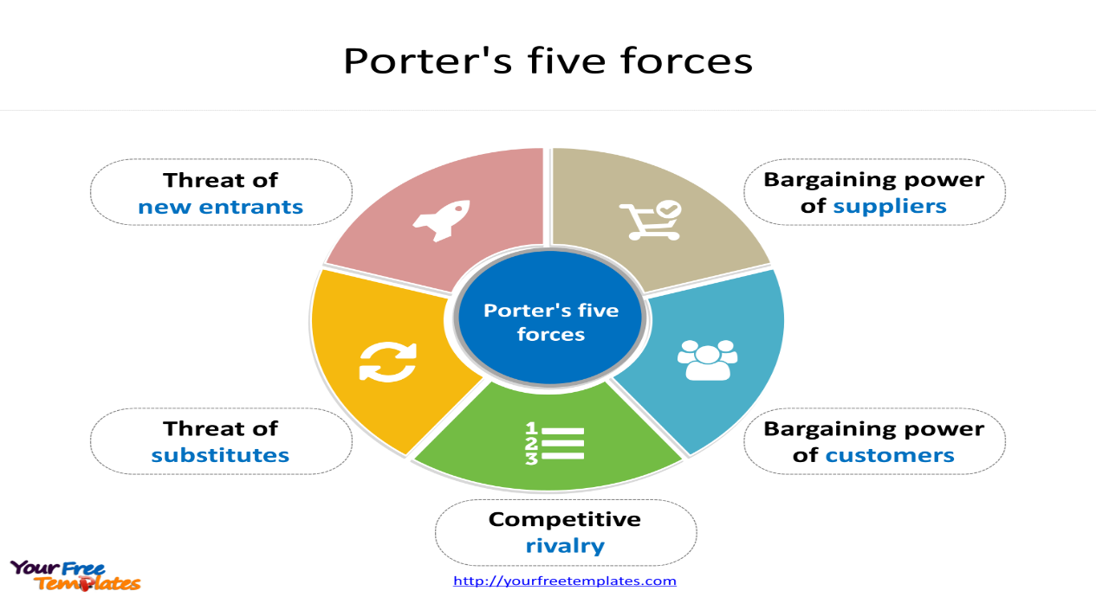

Figure (): Porter's five Forces [23]

The intensity of competition within an industry is influenced by various factors, including the number of competitors, industry growth rates, and the differentiation of products or services. A highly competitive industry may experience price wars, increased marketing expenses, and reduced profitability. The threat of new entrants is another critical factor, as industries with low entry barriers—such as minimal capital investment requirements or weak regulatory constraints—are more vulnerable to disruption from new competitors. Meanwhile, suppliers and buyers play a significant role in determining industry profitability. When suppliers have significant power, they can dictate higher prices for raw materials or services, squeezing profit margins for businesses. Similarly, customers with strong bargaining power can demand lower prices, better quality, or additional services, further influencing profitability. Lastly, the presence of substitute products or services can limit an industry's growth potential, as consumers may switch to alternatives if they offer better value or convenience.

While Porter's Five Forces model remains a valuable tool for analyzing an industry's competitive landscape, it is not without its limitations. The model primarily focuses on external factors and may not fully account for the impact of technological advancements, government regulations, or shifting consumer preferences. Additionally, industries today are increasingly shaped by globalization and digital transformation, factors that were less prominent when the model was first introduced. Therefore, while Porter's framework provides a strong foundation for strategic decision-making, it should be complemented with other analytical tools to gain a more comprehensive understanding of industry dynamics.

Despite these limitations, Porter's Five Forces remains one of the most widely used models in business strategy. It helps companies evaluate market conditions, anticipate competitive threats, and formulate strategies that enhance profitability and long-term success. By continuously monitoring these forces, businesses can better position themselves in an ever-evolving marketplace. [24]

### Application Programming Interface (API)

API is a set of protocols and tools that allow different software applications to communicate with each other. An API acts as a messenger between these systems, allowing them to exchange information and services by handling requests and responses between them. APIs play a critical role in integrating external services, such as retrieving live market data from external databases or search engines. This integration is possible without needing to know the details of how the system works or being built in the same or compatible technologies. An API receives a request from one system, forwards it to the requested target system, and then brings the response back to the original system. As figure 4 shows, an API works just like a waiter in a restaurant, that delivers orders from customers to the chef, then brings back the meal to the customers.

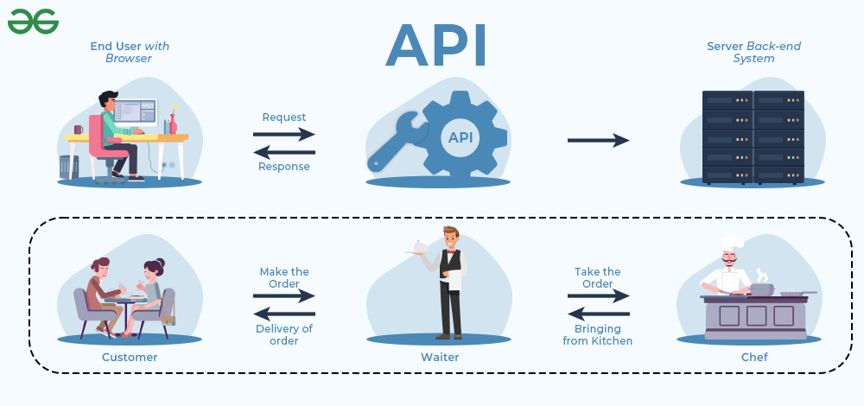

Figure (): API [25]

API Integration is the process of connecting multiple applications through APIs, enabling seamless data exchange and communication. It allows web tools to interact efficiently by facilitating the transfer of information between systems. With the growing adoption of cloud-based solutions, API integration has become essential for modern applications.

In this graduation project, API integration plays a crucial role in enabling the chatbot to retrieve and analyze real-time market data. The system utilizes a *search engine API* to access the latest market trends, competitor insights, and industry statistics from the internet, ensuring that users receive up-to-date information. Additionally, an *LLM API* is integrated to process user queries, generate responses, and provide structured market analysis based on the retrieved data. By leveraging these APIs, the chatbot can dynamically generate insights without relying on a static knowledge base, enhancing its ability to support entrepreneurs in market research and decision-making.

### Artificial Intelligence (AI)

AI can be defined as a computer science technology that can teach computers to understand and emulate human conditions and behaviors. [26] This is one of the many published definitions of AI, to better understand the concept of artificial intelligence, it is necessary to understand the concepts Artificial and Intelligence separately. Intelligence can be described as the natural work of the human mind, such as learning, thinking, reasoning, problem-solving, and rationally acting and performing. While Artificial refers to things made and found by humans, rather than occurring naturally. Now combining these two terms together, Artificial Intelligence, can be referred to as the machines, mainly computers, that have the capability of simulating human intelligence.

The main aim of AI is to produce machines that reproduce human intelligence and cognition by emulating how humans learn and process information, and as a result, performing and acting in the environment. Cognition technologies resemble the action of the human mind, providing the computer the functionality to think, and act just like a human.   
In order to perform an intelligent task, AI agents should not be explicitly programmed and hard-code written, but rather, it should be able to sense, interpret, learn, understand, and extract patterns to act on its own. In other words, AI should be able to properly interpret environmental data, learn from this data, and use this learning and understanding to achieve specific and pre-defined goals and tasks, through flexible adaptation. [27] This data can be structured or semi structured, coming from different sources. AI helps organizations and businesses trach real-time data to analyze and respond efficiently to customers’ ever-changing requirements. [26]

### Machine Learning (ML)

The principle of ML incorporates training algorithms to enable machines to learn how to make accurate predictions. [28] ML Algorithms, also called Learners, are developed to have the capability to learn from large datasets, called inputs of the ML algorithm, and extract patterns from the data, resulting in trained intelligent models that can perform various tasks, and make decisions or predictions without being explicitly programmed.  
In other words, ML provides the machines with the capability of learning from experience. Experience for machines comes from the training data. Unlike normal programs that is a built as a set of instructions transforming inputs to outputs based on predefined rules, ML algorithms take both the input and output as a single unit, called training data, to figure out a model that converts future inputs to output, by discovering patterns and relationships between inputs and outputs in the training data.

Machine Learning can either be considered as a subset or one of the tools of AI. ML can be mainly divided into two categories, supervised, and unsupervised learning.   
Supervised Learning ML Algorithms The training data, include the target value, called the output for each single entry considered as an input. The Algorithm then identifies patterns from the training data. Examples of this approach are classification and prediction.

Unsupervised Learning ML Algorithms, the target value is not included in the training data. The algorithm itself has to solve the problem, through analyzing the structure of the training data and its statistical properties. This approach is often used to discover hidden patterns in the dataset. Examples of this approach are clustering, anomaly detection, and association rules mining. In clustering for example, the model is given things of various types as an input, the model tries to find some patterns on this data and group similar data groups in a cluster, resulting in multiple clusters as an output. [27]

### Generative AI (Gen AI)

Generative AI is a field of Artificial Intelligence focused on generating original new content, including text, images, videos, audio, or software code, based on user prompts or requests. It leverages advanced Machine Learning models, specifically Deep Learning algorithms, which mimic the human brain's learning and decision-making processes. These models analyze patterns and relationships within large datasets to interpret natural language inputs and generate relevant, original content in response.

Gen AI's generativity manifests in various domains, producing outputs that range from simple recombination of existing data to entirely novel and unexpected creations. Unlike traditional AI models that rely on predefined rules, Gen AI continuously evolves, enhancing its ability to produce meaningful and contextually relevant outputs.

Generative AI is not solely about output but also about the learning process and its ability to influence human creativity. Its capability to analyze patterns, recognize trends, and suggest novel solutions makes it an essential tool in modern design, problem-solving, and decision-making. The integration of Gen AI into creative industries highlights its potential to co-create with humans, optimizing workflows and enhancing innovation. However, maintaining a balance between human input and AI-driven automation remains a key challenge. Addressing these complexities is crucial in harnessing Gen AI’s full potential while ensuring responsible and ethical use. [29]

#### How Generative AI Functions?

Generative AI functions by leveraging advanced machine learning techniques, particularly deep learning architectures, to create new data that resembles a given dataset. Unlike discriminative models, which are designed to classify or predict outcomes based on input data, generative models learn the underlying patterns, structures, and distributions of the data to generate novel outputs. This process involves several key components and methodologies, including neural networks, probabilistic models, and optimization techniques.

Generative AI has a wide range of applications, from creating art and music to designing drugs and generating synthetic data for research.

Generative AI typically follows three key stages:

1. Training: Generative AI relies on a foundation model trained on vast amounts of raw, unstructured data to support various applications like text, image, video, and sound generation. These models, such as LLMs, are created by training algorithms to predict sequences, e.g., the next word in a sentence, through millions of "fill-in-the-blank" exercises, refining their parameters to minimize errors. The result is a neural network capable of autonomously generating content based on prompts. However, this training process is resource-intensive, requiring thousands of GPUs, weeks of computation, and significant costs. Open-source projects allow developers to bypass these expenses by using pre-trained models.
2. Tuning: Customizing the foundational model for a specific application or use case. A foundation model is like a generalist, it has broad knowledge but may lack precision for specific tasks. To improve accuracy, the model can be fine-tuned using labeled data relevant to the desired application, such as customer service questions and answers for a chatbot. Fine-tuning, however, is labor-intensive and often outsourced. Alternatively, reinforcement learning with human feedback (RLHF) allows users to evaluate and score the model's outputs, helping it learn and improve over time. This can involve direct interactions, like correcting a chatbot's responses, to enhance its performance.
3. Generation, Evaluation, and Retuning: Producing outputs, assessing their quality, and iterating to enhance accuracy and performance over time. Developers and users regularly evaluate the outputs of their generative AI applications, often fine-tuning the model weekly to enhance accuracy and relevance. In contrast, the underlying foundation model is updated less frequently, typically every year or 18 months. Another method to improve performance is retrieval augmented generation (RAG), a framework that allows the model to access external, up-to-date information beyond its original training data. This supplements and refines the model's parameters, ensuring it stays current. Additionally, RAG provides transparency about the sources used, unlike the opaque knowledge embedded in the foundation model. [30]

### Nature Language Processing (NLP)

NLP is a field of artificial intelligence focused on the interaction between computers and human language. It combines linguistics, computer science, and machine learning to enable machines to analyze and process human language in order to extract insightful information from textual data. As the volume of text data continues to grow, from social media posts to academic papers, NLP has become vital for extracting insights and automating diverse tasks.

NLP has many steps and phase as shown in Figure 5, core concepts in NLP include:

* Syntax: Analyzing the structure of sentences.
* Semantics: Understanding the meaning of words and sentences.
* Pragmatics: Contextual language understanding.

The process begins by gathering textual data from various sources such as surveys, social media comments, and consumer reviews. To enhance the accuracy of sentiment analysis, NLP techniques are applied, including data cleaning, formatting, tokenization, and lemmatization. Tokenization breaks text into individual words or sentences, stop-word removal eliminates common but non-informative words, and lemmatization reduces words to their root forms.  
After preprocessing, feature extraction methods are used to represent text data effectively. The Bag-of-Words (BoW) model treats words as a collective set without considering their order, while Term Frequency-Inverse Document Frequency (TF-IDF) evaluates a word's importance by measuring its frequency in a document relative to the entire dataset. Word embeddings represent words as multidimensional vectors, capturing their semantic relationships.

For sentiment analysis, different models are employed. Rule-based models analyze sentiment using predefined linguistic rules and patterns. More advanced approaches leverage deep learning models, particularly neural networks, which are trained on labeled datasets to recognize complex sentiment patterns and improve classification accuracy. [31]

NLP has several applications in today’s life, including machine translation, sentiment analysis, speech recognition, and information retrieval.

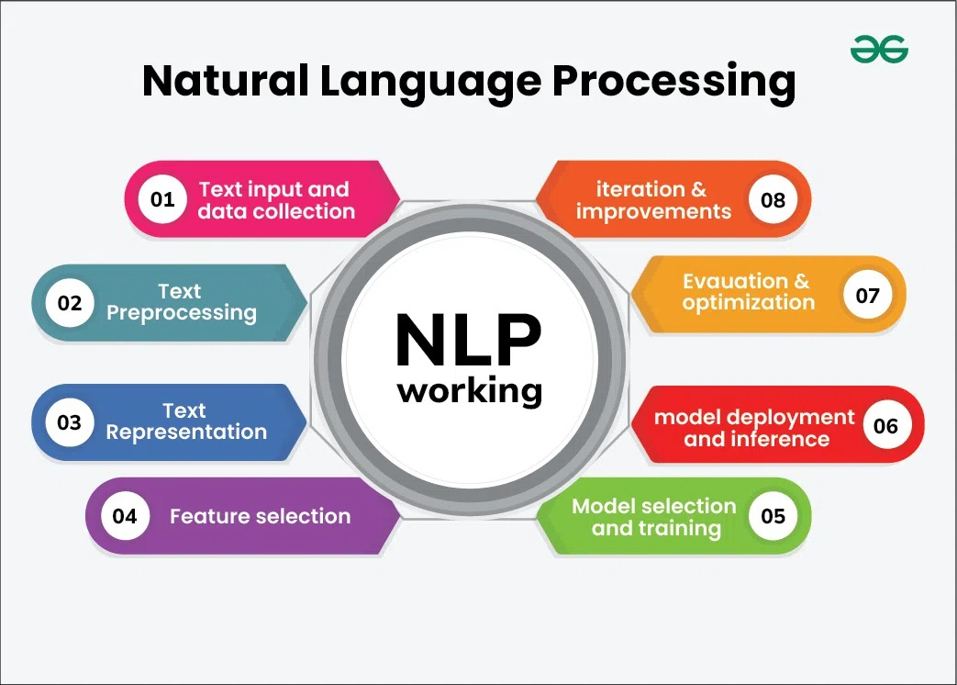

Figure (): Natural Language Processing [32]

### **Large Language Models (LLMs):**

LLMs are advanced AI Systems that are trained on vast amounts of text data to generate human-like language. LLMs are designed to understand and process natural language inputs, and they can then produce relevant text outputs. These models are typically trained on massive amounts of text data, such as books, articles, and websites, and they use complex algorithms to learn and understand patterns and relationships in the language. The development of LLMs has been driven by advancements in deep learning methods, computational resources, and the availability of training data. LLMs have become a crucial tool in NLP, pushing the boundaries of what machines can achieve in understanding and generating human-like text.

Unlike domain-specific models, which require separate training for each use case, LLMs provide a general-purpose foundation that supports multiple applications, reducing costs and improving efficiency. Examples of well-known LLMs include OpenAI’ s GPTs, Meta’s Llama models. These models power applications such as chatbots, virtual assistants, content creation, research tools, and language translation.

LLMs function using deep learning techniques, primarily transformer architectures, which excel at processing sequential data. The Transformer model played a significant role in the development of LLMs by enabling the learning of longer-term dependencies in language and parallel training on multiple GPUs. The training process involves predicting the next word in a sequence based on contextual cues, using billions of parameters and an attention mechanism that refines the model’s understanding of language patterns. Tokenization breaks text into smaller units, which are then converted into embeddings, which are numerical representations that help the model learn grammar, semantics, and conceptual relationships. Training on massive datasets enables LLMs to generate coherent and contextually relevant responses.

Model performance can be improved through techniques such as prompt engineering, fine-tuning, and reinforcement learning with human feedback (RLHF), which help mitigate issues like bias, misinformation, and unwanted content. These refinements ensure that enterprise-grade LLMs are reliable and suitable for real-world applications. As they continue to evolve, LLMs are reshaping how humans interact with technology, making them essential tools in the modern digital landscape. [33]

### Retrieval Augmented Generation (RAG)

Retrieval-Augmented Generation (RAG) is the process of directing the LLM to reference a reliable knowledge base outside of its training data to generate the response in order to optimize it, a knowledge base is a store of data about a product, a service or a topic. RAG extends the capabilities of the LLM such as translating languages and completing sentences, to be used for specific domains or knowledge bases without the need to retrain the model. The knowledge base can come from various data sources including documents like Pdf files, or from the internet, or it can be the organization’s own database (internal data).

LLM training data can be static and out of date, it can provide wrong output when it does not have the answer or even generate responses from unauthorized resources, organizations may use RAG in order to avoid these challenges where they can have greater control over the generated output. A minimalistic diagram represented in figure 6 effectively conveys the RAG concept.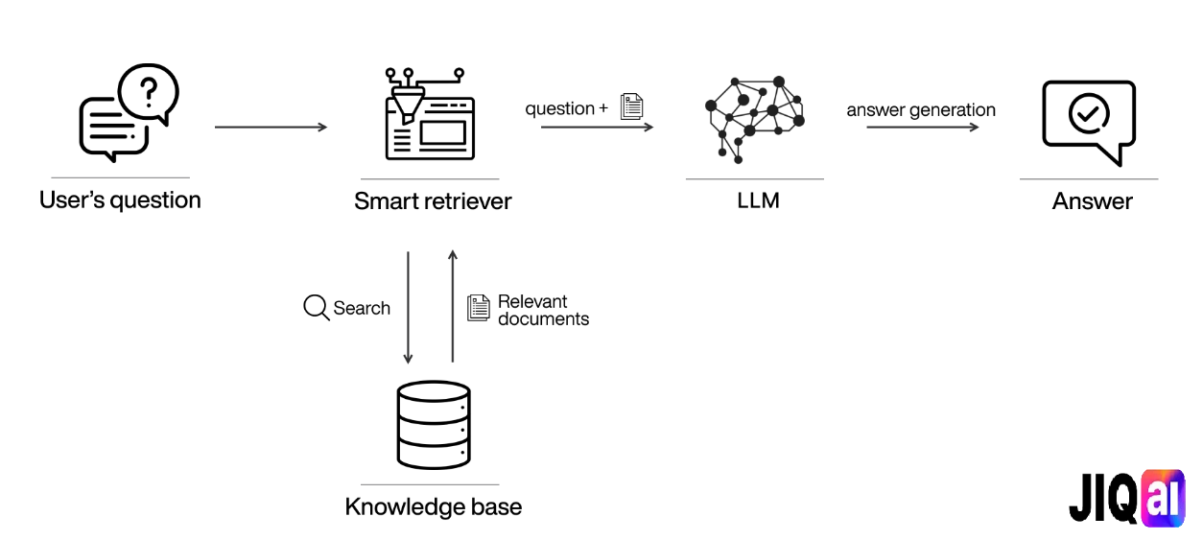

Figure (): RAG Technology [34]

#### Benefits of Using RAG

* Prevents models from hallucinating: Hallucinating is the inaccurate results that are generated by AI models, the data that is used to perform RAG is consistently updated which means the model is more likely to provide more accurate answers.
* Expand the use cases of the model: by feeding the model with extra data, the model will be able to deeply handle different user prompts.
* Generate a customized response: It allows responses to be more precise and tailored to match the user’s query.
* Scalability across domains: RAG can be used for a wide range of different domains without the need to retrain the model, this makes it adaptable for different sectors.
* Resource efficiency: RAG retrieves only the related parts during the generation process, this reduces the load for the model. [35]

#### Benefits of RAG in the context of market analysis

* RAG ensures that the generated market insights, competitor analysis, and trends are up to date, reducing the risk of outdated or misleading information since the data that is used to perform RAG is consistently updated.
* RAG enables the model to retrieve market data specific to the user’s business location and industry instead of relying on a generic dataset, making the analysis highly relevant to the business context.
* RAG can be used for a wide range of different domains without the need to retrain the model, it can dynamically adjust the analysis by retrieving information tailored to the business type.

#### Important Terms

* Vectors: Arrays or list of numbers represents data in a format that AI algorithms can understand, each number represents a specific feature of the data.
* Vector Database: A specialized database used to store vectors.
* Vectorization (Vector Embedding): Is the process of converting data such as words, sentences or other data into vectors that still express the original meaning of the data.
* Chunking: The process of breaking down large data into smaller segments called chunks.

#### How Does RAG Work

1. **Data Preparation:** A knowledge base needs to be prepared so the system can retrieve the information from, the knowledge base consists of documents, articles, research papers and so on, these data should be transformed into numerical vectors using pre-trained embedding models. Text data is firstly split into chunks, each chunk is converted into vectors, these vectors are then saved in the vector database for efficient search.
2. **Query Processing:** There are two components in the process: the retrieval component and the generator component. Retrieval component is used to find the relevant information of a user’s query, by first vectorizing the query the same way used in knowledge base embedding, after that it searches in the vector database for similar embeddings, and then retrieves top-k most relevant results.  
    (For example, top 3 most relevant results), there are 2 types of retrievals: [36]

* Dense Retrievers: Creates dense vector embeddings that capture meaning, they are better when the meaning behind the words is what matters rather than the exact words themselves, this is known as **Semantic Search.**
* Sparse Retrievers: This type prioritize the exact word matching; they work well when the query is specific or contains rare words

1. **Augmenting the LLM with Retrieved Context (final step):** Here comes the role of the generator component, which is the language model that generates the final response, the retrieved results from the previous step and the user’s original query are both sent to the LLM, so instead of answering from model’s pre-trained data, it generates the final response from the retrieved results.

#### **Comparison Between RAG And Semantic Search** [37]

A brief Comparison between the RAG technology and normal semantic search is illustrated briefly in table 1.

Table : Comparison between RAG and Semantic Search

|  |  |  |
| --- | --- | --- |
| Feature | RAG | Semantic Search |
| Primary Function | Augments language models that use real-time information retrieval to generate responses | Improves searching accuracy by understanding the meaning behind the query words |
| Main Components | Data Retrieval methods, Large Language  Models to generate final response based on retrieved information | Semantic algorithms for meaning interpretation, indexing system to convert and store text data |
| Data Source | Can retrieve data from open-domain sources like the internet, or closed-domain such as database that belongs to an organization | Relies on specific knowledge base or database |
| Searching Methodology | Utilizes vector embedding to find relevant chunks that are used to generate the result | Uses natural language understanding to match queries with semantically related data in the knowledge base |
| Use Cases | AI chatbots, personalized recommendation systems, real-time information systems | Data discovery, content management systems. |

#### Challenges in Implementing RAG

* Complexity: With the use of retrieval techniques as well as the generation process, this adds complexity to the model architecture.
* Synchronization: In order to keep the retrieval data up-to-date, a synchronization mechanism is required to handle data updates.
* Latency: Critical applications need real-time responses, and the retrieval process may cause latency, which impacts the response time.
* Missing content in the knowledge base: This may lead the LLM to generate wrong answers.
* Challenges in working with PDFs or text documents: The documents may include embedded tables and charts, making the process of extracting data from them complicated.

# Chapter 2 Related Works

**Chapter 2  
Related Works**

As market analysis continues to develop, several tools and platforms were created to help businesses assess their viability, understand their competition, and make strategic decisions. This chapter explores existing solutions that share similarities with our project, categorizing them into commercial platforms and AI-driven business analysis tools.

## 2.1 Related works (websites/platforms)

**IBISWorld** [38]

A platform for industry market research and reports for several regions, its main goal is to provide market analysis for selected industries so the user could make better strategic decisions, and to discover competitors’ potentials. It depends on the analyst expertise in the industries as well as their knowledge of future movements based on their studies. Primary difference between **IBISWorld** platform and our service is that we use search engine API to fetch data that need to be passed to the LLM for generating the market analysis, we also use a chat-based UI for user interaction. Similar platforms to **IBISWorld**: Statista [13] , Mordor Intelligence [39] and Grand View Research [40]

The following 7 and 8 figures, represent IBISWorld’s report for Furniture sector in the US.

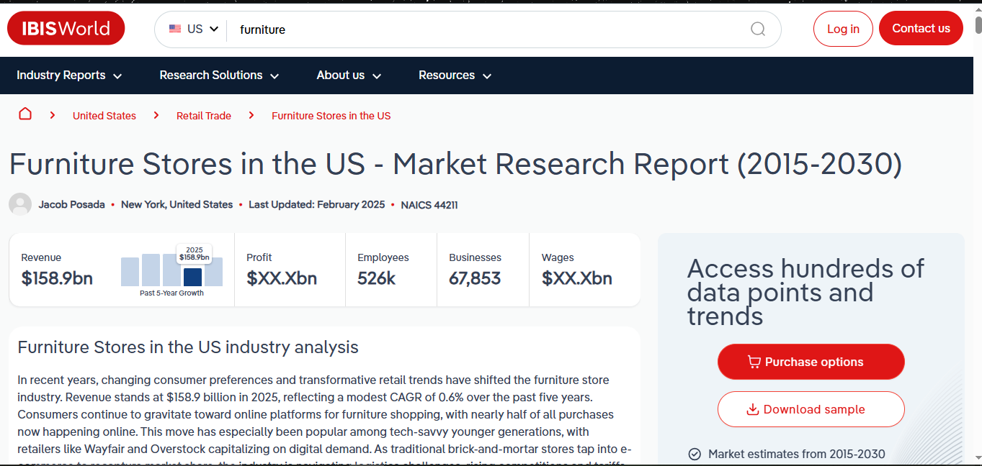

Figure (): IBISWorld - US Furniture use case report - pt 1

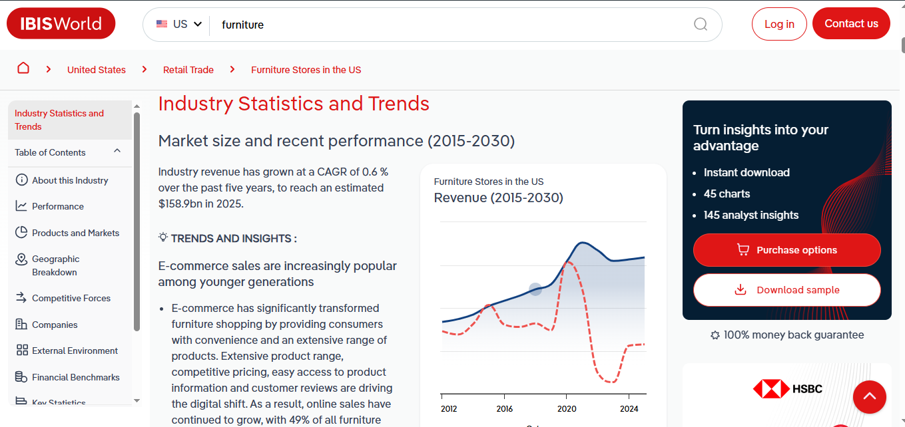

Figure (): IBISWorld - US Furniture use case report - pt 2

**Euromonitor International** [41]

Market and industries data analytics and research platform that provides data for different products and services as well as consumer insights, to help users make better business decisions with necessary guidance they need on how and when to grow their business, using recent data science techniques.

Their methodology focuses on reliability and quality, whether it is their own data or data from other transparent sources.

Compared to Euromonitor International, our service acts as a lightweight, dynamic assistant for market analysis tasks, rather than generating extensive reports or datasets. In terms of data handling and customization, our service provides the output based on user interaction and search results.

Below, figure 9 represents the Retail and e-Commerce Market in the US overview given by Euromonitor International.

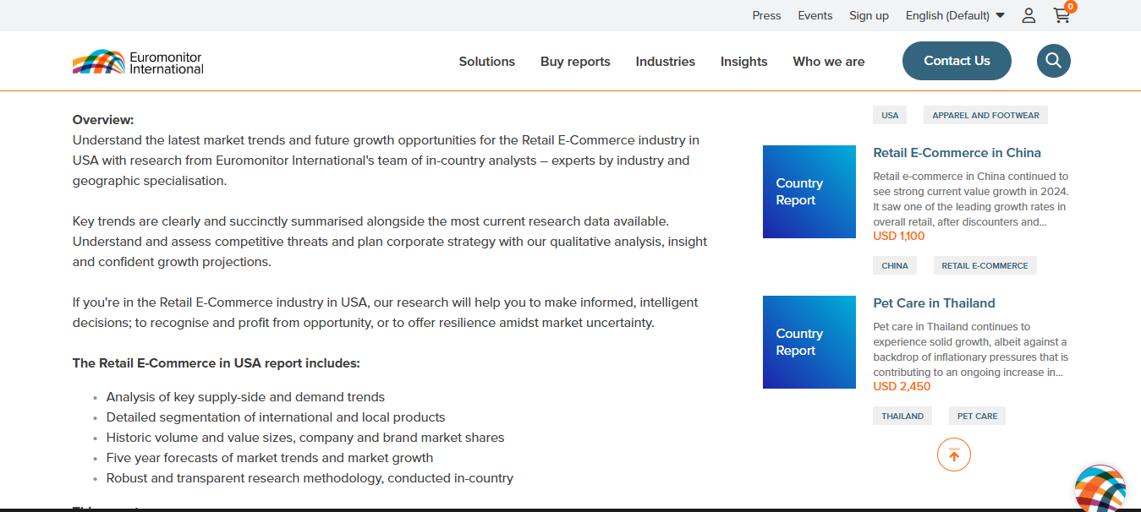

Figure (): Eur. Int. - Retail and e-Commerce Market in the US use case overview

**MyMap.ai** [42]

Platform that offers AI-powered tools used to transform ideas into visual content, among these tools is one that provides a free AI market analysis based on the user’s description of the business including competitor insights, growth potential, expansion insights and market size, it also allows various file types upload, processes the content within the document to finally provide the market analysis, with real-time web search from google and Bing to ensure analyses are up to date.

The differences between MyMap.ai and our service is that it focuses on generating visual market analysis diagrams, while we use text-based market analysis, and in terms of user input and interaction, MyMap.ai accepts input through direct interaction like file upload, and our service starts with a prompt-driven approach, where LLM asks the questions interactively.

Figures 10, 11, and 12 represents diagrams provided by Map.ai, these diagrams illustrate market analysis given a case of coffeeshop offering different types of drinks in New York.

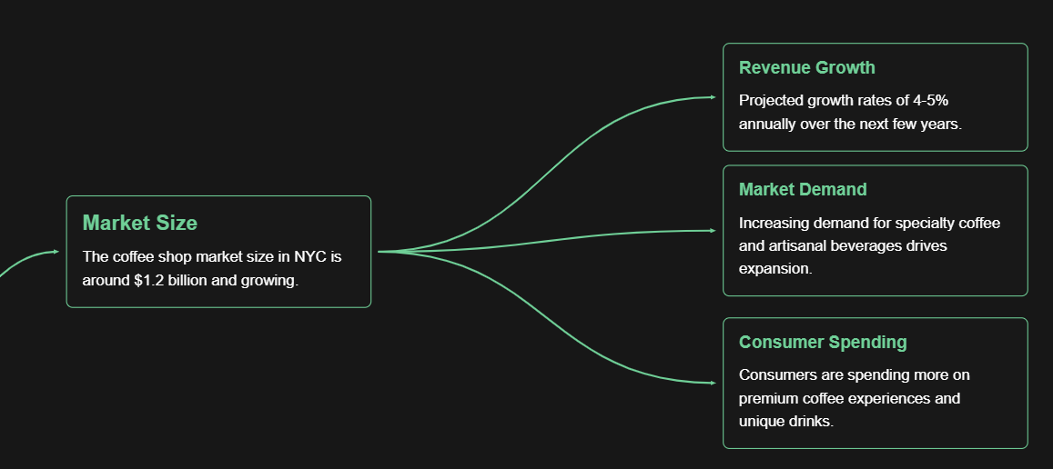

Figure (): Map.ai - Market Analysis Insights for A Coffeeshop In New York

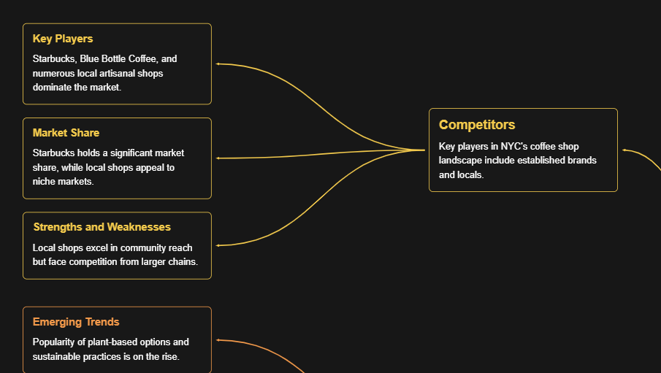

Figure (): Map.ai - Competitor Analysis for A Coffeeshop In New York

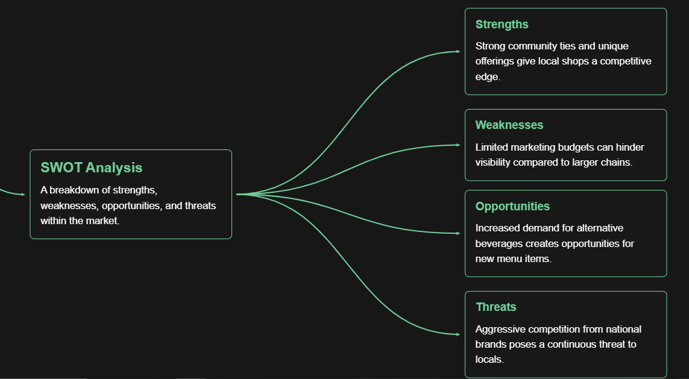

Figure (): Map.ai - SWOT Analysis for A Coffeeshop In New York

**VenturusAI** [43]

In-depth business analysis tool tailored to the proposed venture, including SWOT, PESTEL, and Porter's Five Forces assessments. It also provides insights to the target audience, by leveraging advanced AI models, including GPT-3.5 and GPT-4, VenturusAI evaluates the potential challenges of proposed ventures, to finally offer valuable insights in order to guide decision-making, it conducts in-depth assessments such as SWOT, PESTEL, and Porter's Five Forces analysis. VenturusAI utilizes advanced natural language processing techniques to interpret user’s business ideas.

Key differences with our service are that we are more interactive with the user, while VenturusAI instantly automates the whole analysis with minimal user interaction. Our service is flexible for modifying the large language model through prompt or APIs, but VenturusAI is limited to its main functionalities.

Below, figures 13, 14, 15, and 16 represent business analysis assessment reports generated by VenturusAI, given the use case of a Clothing brand named Emirati Elegance that blends traditional modest fashion with modern trends, offering stylish abayas, kaftans, and everyday wear, based in UAE.

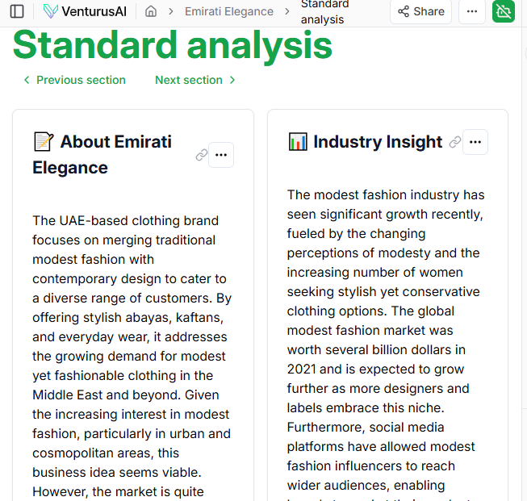



Figure (): VenturusAI - Emirati Elegance Clothing Brand Market Analysis– pt 1

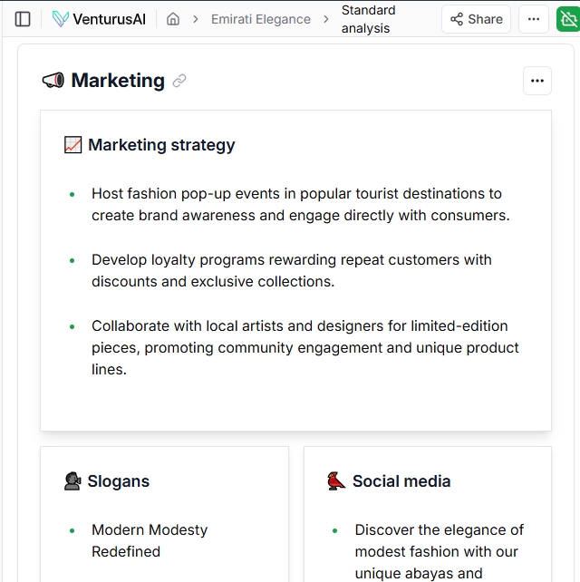

Figure (): VenturusAI - Emirati Elegance Clothing Brand Market Analysis -pt 2

|  |
| --- |
|  |

Figure (): VenturusAI - Emirati Elegance Clothing Brand SWOT Analysis

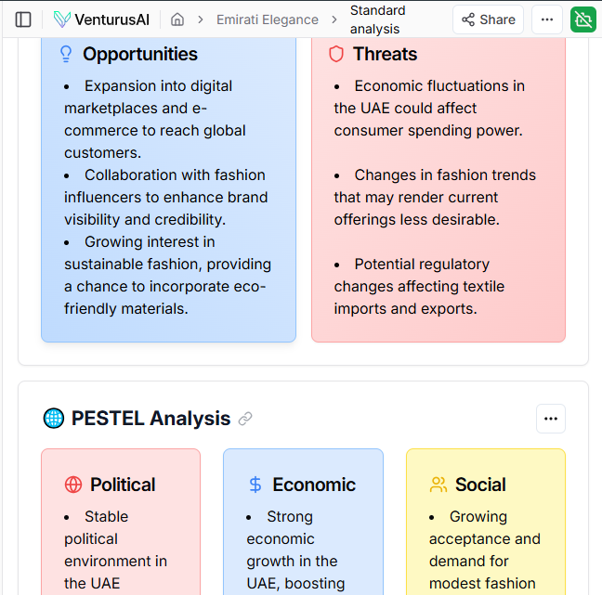

Figure (): VenturusAI - Emirati Elegance Clothing Brand PESTEL Analysis

**Using LLMs for Market Research paper** [44]

explores how AI and large language models (LLMs), are transforming market research and analysis. It shows the potential of LLMs to simulate consumer preferences by generating survey responses that mimic human behavior. The study highlights LLMs as a low-cost, rapid alternative to traditional methods like focus groups and conjoint surveys, with additional potential for fine-tuning responses using existing survey data to improve alignment with real-world consumer preferences. A similar paper that explores the Role of large language models in automating market research: **Determining the Validity of Large Language Models for Automated Perceptual Analysis** [45]

## 2.2 Key Aspects of Related works in comparison to our work

Table 2 below illustrates the previous platforms and paper discussed above comparing key aspects between them and our work

Table : The Key Aspects of Each Platform/Paper

|  |  |  |  |
| --- | --- | --- | --- |
| Platform/Paper | Main Focus | Methods/Approaches | Findings/Highlights |
| IBISWorld | Industry market research and strategic decision-making | Analyst expertise in industries and future movement studies | Provides market analysis and competitor insights for strategic decisions; relies on expert-driven approaches |
| Euromonitor International | Market analytics and consumer insights | Combines proprietary and third-party data using data science techniques | Delivers reliable datasets and reports for business decision-making |
| MyMap.ai | Visual market analysis and competitor insights | AI-powered tools with file upload and integration with search engines (Google and Bing) | Generates visual market diagrams and insights like market size, growth potential, and competitor analysis |
| VenturusAI | In-depth business analysis and decision-making | Advanced AI models (such as GPT-3.5, GPT-4) for SWOT, PESTEL, and Porter’s Five Forces analysis | Automates comprehensive market and business assessments; provides detailed analysis with minimal user interaction |
| Using LLMs for Market Research | AI simulation of consumer preferences for market research | Querying LLMs to simulate survey responses | Highlights LLMs as a low-cost, rapid alternative to traditional methods and shows its potential |
| AI-MAS (Our Work) | AI-powered feasibility analysis for new business ideas | Employs LLM API (Llama 3.2 11B Vision) for structured business assessment and Integrates Bing search engine API for retrieving real-time market data | Generates market analysis, SWOT, competitor insights and customer segmentation |

## 2.3 Summarization and Conclusion

While existing market analysis platforms provide valuable insights, they have limitations such as strict data input methods, or dependence on static datasets. Our system differentiates itself by offering a chatbot-based interface that guides users through a structured sequence of predefined questions, covering key business aspects like location, customer base, and business model. This interactive approach ensures that data collection is tailored to the user's specific business idea. Additionally, the system leverages an LLM model and a search engine API to provide real-time insights, its structured system prompt ensures a consistent questioning flow and a well-organized final report, including SWOT analysis, market size and trends, competitor analysis, and customer segmentation.

# Chapter 3 The Prototype Methodology

**Chapter 3  
Prototype Methodology**

In terms of software methodology, we decided to adopt the *Prototyping Methodology* [46]. The Prototyping Methodology is a software development approach that builds an initial version or prototype of the system before completing the final product. This allows developers and stakeholders to visualize and test key features and functionalities early in the process. It is used when exact system requirements are unclear at the beginning. The prototype is repeatedly refined based on user feedback until it meets expectations. This incremental approach enables flexibility, as changes can be made during the prototyping phase. Early stakeholder involvement helps address misunderstandings quickly, ensuring that the final software aligns with user needs.

The prototype methodology clearly states that it ultimately produces a working prototype of the required system. However, this prototype serves as an early version, providing a tangible representation of the system’s key functionalities. It is not the final, fully operational system, but rather a tool for demonstrating concepts and gathering crucial feedback. The prototype undergoes multiple iterations, where feedback from users and stakeholders is continuously integrated.

This iterative process ensures that improvements are made based on real-world usage and user interaction. It also helps identify potential issues early, reducing the risk of larger problems emerging later in the development process. The prototype evolves into a more refined version with each iteration, and additional features or modifications are applied as necessary.

More work and development are required after the prototype is delivered to fully realize the system. The final product will require more rigorous testing, debugging, and the integration of advanced functionalities to meet all performance, security, and usability standards. This process allows the development team to ensure that the final product is robust, fully functional, and aligned with both technical specifications and user expectations.

## 3.1 The Prototyping Methodology

### 3.1.1 Main concepts in prototyping methodology

The Prototyping Methodology is based on several key concepts that collectively contribute to its effectiveness in software development. At its core, the methodology *follows an iterative approach*, where the system's requirements evolve gradually as development progresses. Prototypes are built, tested, and refined in cycles, allowing for continuous feedback from users and stakeholders. This iterative nature ensures that each version of the prototype improves based on real-world testing and user input, progressively moving closer to the final product.

A central concept in prototyping is *user involvement*. Unlike traditional development methods, which often limit user interaction until later stages, prototyping encourages early and ongoing participation. Users are engaged right from the prototype stage, and their feedback shapes the direction of the development process. This continuous interaction ensures that the system is designed with the end-user in mind, aligning closely with their needs and expectations. By prioritizing user feedback throughout development, prototyping reduces the likelihood of misalignments between the final product and user requirements.

Another important concept is the *creation of a Minimum Viable Product (MVP)*. The MVP is a simplified version of the system that includes only the essential features necessary for early-stage testing and feedback. The MVP allows the development team to test core functionalities without overcommitting resources to unnecessary features. This approach not only accelerates the development process but also enables the identification of key issues and improvements before investing significant time and effort into the full system.

*Risk reduction* is a crucial advantage of the prototyping methodology. By building and evaluating prototypes early, developers can identify and address potential risks in the system before they escalate. This proactive approach allows teams to focus on resolving critical problems at the earliest stages, rather than discovering them late in development. The ability to test and validate concepts early in the process reduces the overall risk of project failure, making prototyping a valuable tool for managing uncertainty in software development.

Overall, the prototyping methodology is characterized by its adaptability, user-centered focus, and risk-conscious approach, all of which contribute to the development of a system that closely meets user needs while minimizing the potential for costly issues down the line.

### 3.1.2 Key Practices and Phases of Prototyping Methodology

The Prototyping Methodology is implemented through a series of iterative phases, ensuring continuous development and improvement based on user feedback. Each phase is built upon the previous one, allowing the system to evolve and align closely with user needs. The following key practices and phases outline how the methodology is applied as shown briefly in figure 17:

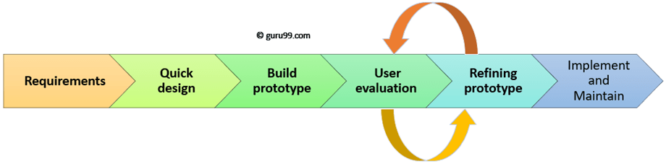

Figure (): Prototype Methodology

1. Requirements Gathering and Initial Planning
   * During this phase, the core functionalities of the system are identified. This includes defining the essential features such as user input handling, real-time data retrieval, and response generation. A clear understanding of these functionalities forms the foundation for the prototype.
   * The integration strategies for the LLM (Large Language Model) and the search engine API is determined, ensuring that the system can leverage real-time data retrieval and generate accurate, context-sensitive responses.
2. Quick Design
   * This phase provides a high-level design of the system, focusing on the user interface, interaction flows, and architecture.
   * A rough prototype is developed to represent the layout and user experience, helping to visualize how users will interact with the system and guiding the development process.
   * In this phase we develop a simple interface that contains the main screen to interact with the model, containing buttons and text box.
   * The design phase helps identify potential design challenges early, making it easier to refine the system's architecture before jumping into actual development.
3. Prototype Development
   * The development of the initial prototype begins by creating a basic version of the system. In our case, we develop a simple chatbot with a Gradio interface. This allows for quick deployment and testing.
   * Core response generation capabilities are integrated. The goal is to create a working version of the chatbot quickly, enabling early feedback and further refinement later.
4. User Feedback and Refinement
   * User testing sessions are conducted between team members to gather insights from our testing and use cases. Feedbacks focus on the chatbot’s ability to provide meaningful responses and its ease of use.
   * Based on the feedback, adjustments are made to both the chatbot’s responses and the underlying data processing logic. This allows the prototype to evolve in a way that better suited user expectations and practical needs.
   * In the beginning, we use the Gradio’ s built in chatbot interface, then we start to add functionalities, including connecting to the LLM’s API, then integrating with a search engine’s API, then enhancing the model’s responses.
5. Enhancements and Testing
   * After incorporating feedback, enhancements are made to improve the system’s functionality. This includes refining prompt engineering to generate more accurate responses and enhancing search query capabilities for more relevant results.
   * Functional and usability testing are conducted to ensure system stability and accuracy. Testing helps identify potential performance issues and allows the team to address any bugs or usability concerns before moving to the next phase.
6. Final Prototype and Deployment
   * The final prototype underwent optimization, focusing on improving performance, response speed, and integration with the APIs. This is crucial to ensure a seamless experience for users.

Throughout these phases, the methodology emphasizes flexibility, iterative refinement, and user-centric development. Each phase plays a vital role in shaping the system into one that is not only functional but also aligns with user needs and expectations.

### 3.1.3 Types of prototyping in software development

There are different types of prototyping used in software development:

* Rapid Throwaway Prototyping: Useful when requirements are unclear, allowing for several iterations to refine the concept before final development.
* Evolutionary Prototyping: Continuously improves the prototype until it becomes the final system, minimizing the effort required to restart from scratch in each iteration.
* Incremental Prototyping: The system is broken into smaller components that are developed separately and later merged into a complete product.
* Extreme Prototyping: this type is mainly used for web development and consists of three phases:
  + Prototype for all existing pages presented in HTML format
  + Functional screens are made with a simulated data process using a prototype services layer.
  + Developing the actual functional system.

For this project, *Evolutionary Prototyping* was chosen as it allows continuous improvement of the chatbot based on user feedback and evolving market analysis needs. [46]

## 3.2 Reasons for adopting the prototyping methodology in our system development

The nature of our project aligns well with prototyping because we are developing an initial prototype rather than a fully completed system. Our approach involves incremental feature additions and continuous improvements based on feedback. Additionally, since this project is a learning experience for us, we research and learn new concepts as we implement them.

One key reason is ***iterative development and refinement***. The chatbot requires ongoing improvements as we explore different techniques and gather insights from user interactions, which is our testing and trials as a team through the development phase. The structured question flow may need adjustments based on **responses, and prototyping enables early feedback to refine these structures and outputs effectively.**

*Handling uncertain and evolving**requirements* is another critical factor. Market analysis involves dynamic elements, and prototyping allows us to experiment with different prompt structures and refine the output format as needed. This adaptability ensures that the chatbot remains relevant to real-world market conditions.  
**And every time new features were added, some issues were discovered that needed to be modified or complemented with additional elements or adjustments, and these were addressed and implemented during the iterative development process.**

Prototyping also helps in *reducing potential risks.* Instead of developing the entire chatbot at once, we start with an initial prototype to identify limitations early, allowing us to adjust before moving to full development. This approach minimizes costly errors and ensures a stronger final system.

Lastly, the methodology provides *flexibility for model adaptation*. Since we are learning and adapting as we progress, prototyping allows us to explore different methods and adjust our approach as needed. For example, we initially considered using Retrieval-Augmented Generation (RAG) but later shifted to a structured prompt approach. This adaptability ensures that the chatbot evolves in alignment with the most effective and efficient techniques available.

## 3.3 Adaptations and Modifications to the Prototype methodology

During the development of our system, we made some modifications to the original methodology process in order to improve the system’s performance, enhance data accuracy and to ensure a better user experience. The following points are the key adaptations made throughout the development process:

1. **Adjusting System’s Requirements:**

At the beginning we conducted a certain requirements gathering process for the system, our original plan was implementing RAG concept where the model can retrieve data from the knowledge base we structured, we have collected a set of data documents related to markets in the Arabian Gulf and we focused on specific fields including financials, architecture, the market data we selected included market sizes, market opportunities and market insights, however, gathering competitor’s data was challenging, we did not have access to necessary information that we needed to feed the model with to generate competitor analysis, a second major issue was the fact that RAG requires a predefined dataset, but the market conditions change frequently, making it less effective for real-time results.

We realized that we need a more effective approach to build our system, so regathering the requirements was important to achieve accuracy, we searched for different market research analyzing methodologies that need to be real-time data retrieval, which led to modifications in our data acquisition strategy, thus we switched to search engine API integration with the LLM API to analyze the market information and generate the final response.

This adjustment impacted the development by improving accuracy and retrieving up-to-date results. It also simplified the data maintenance process, as there was no longer a need to manage a separate database.

1. **Delayed Design Phase:**

In prototyping software methodology, user interface design is one of the first components to be developed, to ensure that the system’s structure is set before integrating the functionalities, however in our development process we made adjustment to this approach, instead of building the chatbot interface, we first focused on testing the core components of the project, which are the LLM and the search engine API. The reasons behind this adjustment are mainly to ensure the high-quality responses from LLM before considering how the users would interact with it. We tested different LLMs in isolation including models from Hugging Face and other providers to determine which one is the most effective for our system. Similarly, we tested multiple search engine APIs, evaluating their ability to retrieve real-time, accurate market data. By testing these two core components we ensured that they are functioning well on their own before integrating them with the chatbot interface, this allowed us to refine the quality of responses before worrying about user interaction.

## 3.4 Tools and Equipment

### 3.4.1 Tools

1. Programming and Development

* Python (with necessary libraries: Gradio, requests, HuggingFace, etc.)
* Visual Studio Code (IDE)
* GitHub (Version Control)
* Gradio (UI for AI models)
* Hugging Face (Model Hosting & Inference)
* API Integration (Search Engine APIs, LLM APIs)

1. Project Management and Collaboration

* Trello (Task Management)
* Google Meet (Virtual Meetings)
* Telegram (Team Communication)
* Email
* Google Calendar (Scheduling & Reminders)
* Google Drive (Cloud Storage & File Sharing)

1. Documentation

* Microsoft Word (Documentation & Reports)
* Google Docs (Collaborative Documentation)

1. Research and Real-Time Data Retrieval

* Search Engine APIs (Google Custom Search, Bing API, Serp API)
* LLM APIs (OpenAI API, Llama API)
* ResearchGate, Google Scholar, Springer, CORE (research papers and scientific documents)

### 3.4.2 Equipment

1. Hardware

* Personal Computers/Laptops (for development and testing)

## 3.5 Time Table

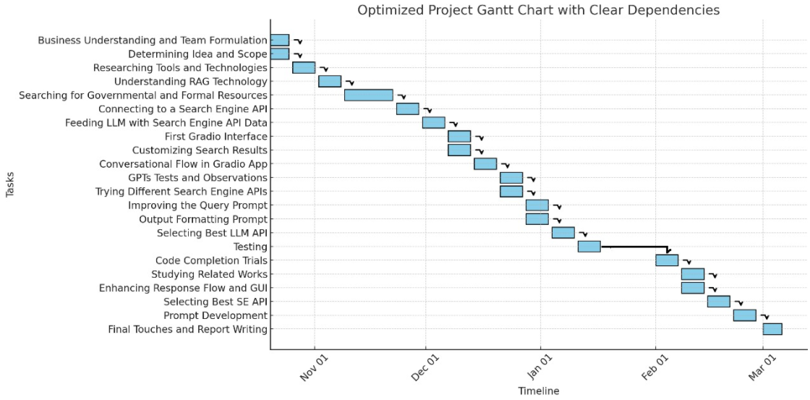

Figure (): Time Table

## ****3.6 Team Management****

### ****3.6.1 Team Structure and Roles****

Each team member has a specific role that contributes to the project's success:

* **Rose – Team Leader**
  + **Rose as a Team Leader:**
    - Understanding business needs and analyzing relevant reports and projects
    - Leading the team, planning, and task allocation
    - Managing accounts, links, and cloud storage and hosting
  + Conducting the initial integration between system APIs
  + Testing various search engines and integrating them with the chatbot
  + Optimizing the system prompt for the result formulation and the schema of questions and results given a market analysis study form.
  + In the Proposal Document:
    - Document management
    - The study summary in Arabic
    - Chapter 1 (Introduction)
    - Team management related sections in Chapter 3 (Methodology)
    - Methodology phases section in Chapter 3 (Methodology)
    - Chapter 4 (Requirements gathering)
    - Chapter 6 (Initial Prototype Development)
    - Chapter 7 (Design and User Interface)
    - Chapter 9 (Experiments: SE APIs Evaluation)
    - Chapter 10 (Future Works)
* **Laila** 
  + Developing and launching Gradio-based interfaces
  + Evaluating AI chatbots such as ChatGPT, Llama, and others
  + Testing and selecting the most suitable LLM models
  + Researching and experimenting with related projects and websites
  + Enhancing model performance and monitoring its efficiency throughout development, by optimizing a system prompt
  + In the Proposal Document:
    - RAG description in the background section, Chapter 1 (Introduction)
    - Chapter 2(related works)
    - Chapter 3(Methodology)
    - Chapter 5(Pre-Development Phase)
    - Chapter 8(Prototype Development: Testing and Refinement)
    - Chapter 9(Experiments)
    - Chapter 10 (Conclusion)

### ****3.6.2 Communication and Collaboration****

* **Meetings:** Weekly (at least one meeting a week) virtual meetings for progress updates and planning.
* **Tools:** Trello for task management, Telegram for quick updates, Google Meet for discussions, and Google Drive for sharing files and documents.
* **Version Control:** GitHub for collaborative development and version management.

### ****3.6.3 Task Assignment and Timeline****

* Task progress tracked using **Trello (Kanban board)**
* Key milestones include:
  + Initial prototype development
  + RAG understanding
  + LLM integration and chatbot testing
  + Integrating Search Engine to LLM API and chatbot testing
  + Determining the best APIs to use.
  + Performance evaluation and final improvements.

### ****3.6.4 Conflict Resolution****

As a two-member team, we maintain open communication and mutual understanding, ensuring smooth collaboration. No conflicts or misunderstandings have arisen, and tasks are handled effectively through shared decision-making.

# Chapter 4 Requirements Gathering

**Chapter 4  
Requirements Gathering**

Requirements gathering is a key step in developing the chatbot for market analysis. This phase ensures the system meets user needs and works within the defined scope. The chatbot is designed to help students, entrepreneurs, SME owners, business analysts, and investors by providing market insights, SWOT analysis, competitor analysis, and customer segmentation. Initially, the project considers using Retrieval-Augmented Generation (RAG) technology to generate responses based on a predefined knowledge base.   
However, after further evaluation, the approach shifts to integrating an LLM API with a search engine API for real-time data retrieval. This change allows for up-to-date market insights without the limitations of a static knowledge base.

This chapter covers the methodology used for gathering requirements, the system’s functional and non-functional requirements, and challenges faced during the process.

## 4.1 Methodology for Requirements Gathering

The requirements gathering process for the chatbot follows a structured approach based on self-driven research, internal discussions, and iterative refinement. We identify key system functionalities by analyzing existing market analysis tools, studying similar AI-driven business assistants, and reviewing literature on chatbot-based market intelligence.

A major part of this process is market research, where we explore online platforms that provide market insights, competitor analysis, SWOT analysis, and business intelligence reports. By studying their features, strengths, and weaknesses, we identify gaps that our chatbot can address. We also conduct a competitive analysis by evaluating AI-driven business assistants and chatbots to understand their data retrieval methods, user interactions, and analysis generation. This helps us benchmark functionalities and determine improvements for our system.

Since this project is part of our graduation work, we refine requirements through iterative brainstorming. By simulating user interactions and testing scenarios, we identify usability challenges and adjust the system’s scope. Instead of external interviews or surveys, we rely on logical assumptions about how users like entrepreneurs, business students, and small investors would engage with the chatbot. To validate these assumptions, we seek guidance from market research experts who provide mentorship and insights into effective market studies. We also reference academic and industry sources to confirm essential market analysis features.

To further refine requirements, we use prototyping techniques by creating low-fidelity mockups. These early designs help us visualize the chatbot’s workflow, refine input and output structures, and adjust the interaction model before development. This iterative approach ensures well-defined requirements aligned with real use cases, even without external stakeholder input.

## 4.2 Functional Requirements for AI-MAS

The chatbot must include key functionalities to help users conduct market analysis efficiently. These requirements define how the system should operate to achieve its purpose.

Below, table 3 presents the criteria we used to determine the priority of both functional and non-functional requirements.

Table : Functional and Non-Functional Requirements Priority Criteria

|  |  |  |
| --- | --- | --- |
| Criteria | Scale Of the Criterion | Explanation |
| Priority | High | indicates essential requirements |
| Medium | indicates important but not critical |
| Low | indicates desirable but not crucial. |

Below, table 4 presents the functional requirements for our system, given the criteria shown in table 3.

Table : Functional Requirements for AI-MAS

|  |  |  |  |
| --- | --- | --- | --- |
| Requirement Name | Requirement Description | Priority | Notes |
| User Input Handling | The chatbot allows users to provide structured input to ensure relevant and accurate market insights. Users can enter details such as geographical location, sector, proposed business model, potential customer segment, and unique advantages. It offers clarification prompts or predefined response options to simplify interaction and prevent confusion. | High | Input via chatbot interface is provided via a textbox |
| Real-Time Data Retrieval | The chatbot integrates with an LLM API for natural language understanding and a search engine API to fetch real-time market data. It analyzes user queries, extracts key parameters, and retrieves up-to-date information on market size, industry trends, and competitor activity. This ensures responses remain relevant and reflect current market conditions, avoiding outdated insights. | Medium | Data retrieved from search engine API and processed by LLM API. The priority of this integration is medium as the model can depend on its own knowledge when the retrieval fails, but it will not be providing up-to-date information. |
| Market Analysis Generation | The chatbot processes retrieved data and generates detailed market insights based on user input. These insights include estimated market size, industry trends, a SWOT analysis, and an overview of major competitors and potential customer segments. The structured analysis is easy to understand and provides actionable information for decision-making. | High | LLM API generates the MAS after gathering all necessary information from the user, the result is provided as a single message in the conversation. |
| Conversational Flow and Guidance | The chatbot structures the conversation logically, guiding users through each step. It asks relevant follow-up questions and provides examples to help users formulate their queries effectively. | High | LLM API generates the competitor analysis. |
| User Request Handling and Editing | The chatbot allows users to request modifications to their previous inputs or generated insights. If a user wants a refinement to the provided result (MAS) by the model. | Low |  |

## 4.3 Non-Functional Requirements for AI-MAS

Beyond its functional capabilities, the chatbot must meet key non-functional requirements to ensure performance, security, and usability. These requirements define the system’s quality attributes, including usability, scalability, reliability, performance, availability, and security. Since this project focuses on developing a prototype, the priority is on usability and scalability, while other non-functional aspects will be considered in a full-scale application.

Below, table 5 presents the non-functional requirements of the system. The priority scales are previously explained in table 3.

Table : Non-Functional Requirements for AI-MAS

|  |  |  |  |
| --- | --- | --- | --- |
| Requirement Name | Requirement Description | Priority | Notes |
| Usability and User Experience | The chatbot provides a simple and user-friendly interface with clear instructions, structured conversation flows, and accessible features. Users can interact smoothly without technical expertise. It is designed for both beginners and experienced users in market analysis, ensuring accessibility for all. | High | Ensures data is current and relevant |
| Scalability and Concurrent Users | The system can handle multiple users simultaneously without performance issues. Since market analysis is conducted by different users at various times, the chatbot efficiently distributes processing loads. Its architecture supports future scalability, allowing expansion without major redesigns, which can be achieved by upgrading to a higher plan based on user demand. | Medium | Ensuring broad accessibility |

## 4.4 Challenges and Considerations

During the requirements gathering phase, we face several challenges that shape our approach. We carefully address these to ensure the chatbot is practical, effective, and aligned with its purpose.

• **Ambiguity in User Needs:** Without direct interviews, defining precise requirements based on assumptions is difficult. To address this, we rely on market research, competitive analysis, and guidance from market study experts. This helps us better understand what users expect from a market analysis chatbot.

**• Using RAG Technology**: One major challenge is considering RAG technology for market analysis. We realize that the available data is too limited to create a comprehensive knowledge base. Many industry reports and financial data are not publicly accessible, and private companies rarely disclose key information. While publicly traded companies provide financial reports, this alone does not give a full market overview. Relying only on such data could lead to incomplete or misleading insights. Given these limitations, we decide that RAG is not the best option. Instead, we integrate an LLM API and a search engine API to retrieve real-time market data, allowing access to more diverse and up-to-date insights.

• **Data Availability and Integration Issues:** The chatbot relies on real-time market data, but APIs come with challenges like rate limits, restricted access, and inconsistent formats. Some online data may also be unreliable. We carefully select APIs that provide structured, high-quality information while ensuring fast and accurate retrieval.

• **Balancing Complexity and Usability:** Advanced market analysis tools often present complex data, which can be overwhelming for non-experts. Our challenge is to simplify data presentation while maintaining accuracy. We structure responses in a conversational format and include guidance to help users interpret results easily.

• **Ensuring a Smooth Conversational Flow:** Since the chatbot interacts through conversation, designing a structured yet flexible dialogue system is challenging. It must recognize vague or incomplete inputs and provide clarification while keeping the conversation natural. We address this by implementing predefined prompts, response suggestions, and interactive guidance to create a smooth and engaging user experience.

## 4.5 System architecture

The system architecture provides an overview of the key components and their interactions within the system. Figure 19 presents a diagram illustrates the structure, highlighting the data flow and integration between the system core modules.

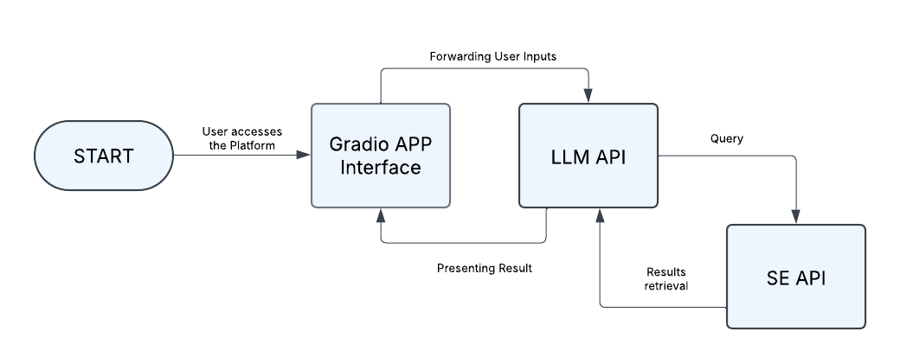

Figure (): System Architecture

## 4.6 User Cases

Since this is a prototype, the system does not include a database or user authentication features such as login and registration. The focus is on demonstrating the chatbot’s core functionality rather than implementing full-scale user management.

Figure 20 illustrates the main use case, where the user accesses the chatbot and starts chatting with.

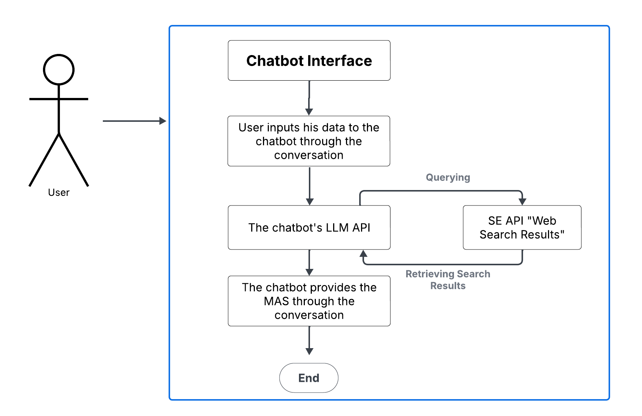

Figure (): Main Use Case

While figure 21, illustrates the situation, when the user requests and edit to the provided MAS result.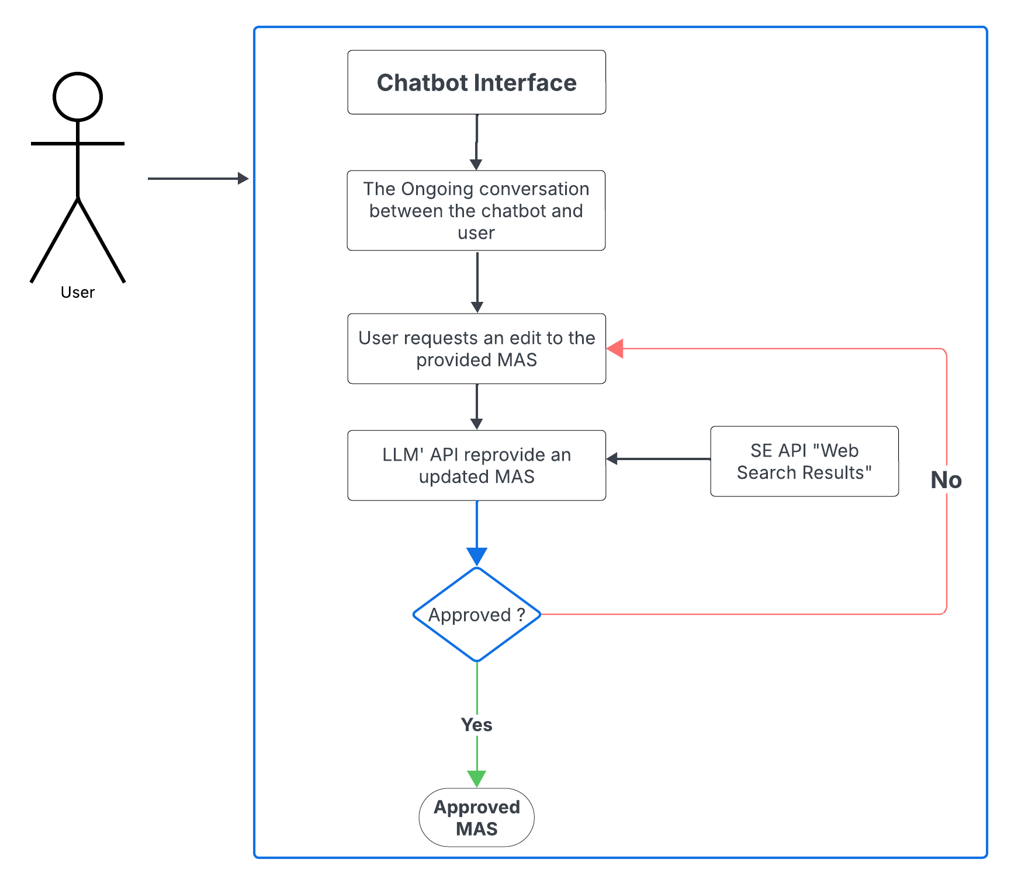

Figure (): Request Edit Use Case

## 4.7 Conclusion

The requirements gathering phase lays a clear foundation for our chatbot by defining its functionalities, constraints, and design considerations. Initially, we considered RAG technology but found it impractical due to limited publicly available industry data and the lack of comprehensive datasets for private businesses. This led us to adopt real-time data retrieval using an LLM API and a search engine API, allowing for more relevant and up-to-date insights.

We encountered challenges such as data reliability, balancing complexity with usability, and refining the chatbot’s conversational flow. Since market analysis involves detailed insights, we focused on structuring responses to be both informative and easy to understand. To ensure smooth interaction, we implemented guided input mechanisms and response generation strategies.

With the functional and non-functional requirements clearly defined, we now move to the next phases, implementing system design, integrating APIs, and refining the chatbot’s ability to generate meaningful market insights.

# Chapter 5 Pre-Development Phase

**Chapter 5  
Pre-Development Phase**

This chapter explains the research, understanding, preparation, and selection of methodologies and techniques to begin the prototype development process. It outlines the available options and how we evaluated them before actual implementation.

## 5.1 Problem Definition and System Goals

It’s critical to carefully study the market before starting a business to ensure its viability. Most entrepreneurs, before starting their business, often struggle with questions about whether there is enough demand for their product or service, who their competitors are and how they can be different from them, and what challenges they may face or opportunities they can leverage. Answering such questions requires extensive research using industry reports, competitor analysis, and financial feasibility studies, which can be time-consuming and difficult for those with little experience in market research. Additionally, hiring a market analyst can be costly.

This is where our AI-powered market analysis chatbot provides a solution. The goal is to create a system that simplifies market research, allowing entrepreneurs to evaluate their business quickly and affordably. Instead of spending weeks researching the market, users can interact with the chatbot, which acts as a market analyst by asking structured questions and generating a market study in a short time.

We establish clear objectives to ensure the chatbot delivers insightful market analysis. The primary goal is to develop a system capable of providing real-time, accurate data, enabling users to track the latest competitor movements and industry shifts, which is essential for making informed business decisions. Another critical goal is to ensure the system generates high-quality analysis, meaning the chatbot should not only retrieve information but also interpret and structure it in a meaningful way. To enhance user experience, we design the system to be interactive, allowing users to engage with the chatbot instead of manually entering lengthy business details. The chatbot asks a series of structured questions to gather essential information needed for analysis. Lastly, we aim to generate a clear, well-structured report highlighting key insights such as market size, SWOT analysis, and competitor insights.

## 5.2 Literature Review: Understanding Market Analysis and AI’s Role in Business Research

Before starting development, we need a strong foundation in market analysis to ensure our chatbot would provide meaningful and accurate insights for evaluating business ideas. This requires extensive research into market analysis methodologies and how artificial intelligence is transforming business research.

Once we had a better understanding of market analysis, we focused on how artificial intelligence is integrated into business research. AI enables businesses to process big amounts of data and generate insights faster than human analysts alone. By reviewing case studies and industry reports, we learn how AI tools already help businesses with market research, customer segmentation, and competitor analysis. We focus on the potential of LLMs and Generative AI to enhance the chatbot’s capabilities. Unlike traditional search engines, which return lists of results, LLMs understand unstructured data, summarize key points, and provide actionable recommendations based on the data retrieved. This makes LLMs an invaluable tool in business research, where speed and precision are essential.

In conclusion, the literature review plays an important role in determining our chatbot’s functionality and the user interaction flow, we want to create a system that could guide users through a structured, interactive process, ensuring that they receive, insightful market analysis, and by studying AI’s capabilities, we determine the best ways to integrate LLMs and search engine into the process, ensuring that the system could generate high-quality and real-time data.

## 5.3 Interfaces and technology Selection

One of the most important decisions we have to make is choosing the platform and interface for our system. The decision is about ensuring that the interface is efficient and user-friendly and capable of integrating with the LLM model. Initially, we considered building our system’s interface using Laravel framework, which is a PHP-based web framework for building web applications or Django framework which is a Python-based web framework, both of these frameworks can be used for API integrations. Since Laravel is known for its clear architecture, easy management for user data, and its structured API, it is a good first choice, However, integrating models and AI APIs in a PHP-based environment is not as straightforward as in Python, which causes potential limitations. As for Django, it seems a more suitable choice since it is a Python-based framework so it will allow easier API integration with AI models, it can manage user inputs and chatbot interactions.

However, using Laravel or Django requires building a custom front-end for the chatbot interface, as well as building an API system for model integration with the interface, which leads to additional effort and development time. Since our main objective is building an AI-powered system, we need a more direct and efficient way without spending too much time on the design, so we finally decided to use Gradio in our system. Gradio is an open-source python package that allows to quickly create customizable UI components for machine learning models, it also allows developers to deploy AI models as web-based applications with less effort. Gradio is a better choice for its quick and easy deployment, unlike traditional web frameworks that require setting up HTML, CSS and JavaScript files beside the API integration, Gradio allows to create a functional web-based chatbot in just a few lines of code, it has built-in user interface components such as textboxes and chat-like interfaces which simplifies the process of building the interface

Additionally, it has a simpler connection with AI models, rather than relying on back-end API integration from other web frameworks. Gradio is also considered scalable, it is flexible for future improvements such as adding extra elements or additional functionalities needed for the system. It does not require setting up a full stack application and it is considered a lightweight web application.

Throughout our exploration of different frameworks, we prioritize efficiency, AI seamless integration, and user experience. While Laravel and Django offer excellent web development capabilities, they are not the most efficient choices for a system that focuses on AI-driven interactions. While Gradio offers an easier connection between AI processing and user interaction, allowing us to build an interactive, and intelligent chatbot that helps users evaluate their business ideas.

## 5.4 Exploration of RAG

RAG (Retrieval-Augmented Generation) is a technique in AI that enhances response accuracy. Instead of relying solely on the pre-trained model’s data, it uses an external, reliable knowledge base to generate final responses. This approach ensures more accurate and real-time answers by combining the user's query with data retrieved from the knowledge base, which is then fed to the LLM to generate the response. RAG is commonly applied in chatbots.

Initially, we plan to adopt the RAG concept for our system, as it combines data retrieval and generative AI, which we believe would provide well-informed market analysis. Our idea is to build a custom knowledge base, collecting and storing data about market trends, competitor insights, and industry reports. We intend for the LLM to access relevant information from this repository when generating responses.

To implement the RAG concept, we start by collecting data from online resources related to the Arabian Gulf market in pre-selected sectors considering this as our initially determined scope of study and the targeted market for the chatbot, saving these resources in various document formats. Our plan is to extract content from these documents, convert them to markdown format, and apply vectorization to store the vectors in a vector database, following the RAG process.

However, as we begin searching for competitor-related data, we quickly encounter significant limitations. The first challenge is the lack of freely available, reliable competitor information. Unlike consumer behavior data or market trends, which are often discussed in reports, articles, or market research papers, competitor insights tend to be more tightly controlled. In many industries, companies either keep this information proprietary or share it through paid reports or membership-based platforms. This means that the content we need to fill out our knowledge base simply is not as accessible as we had hoped.

We spend a considerable amount of time searching online databases, company websites, news articles, and industry reports. Many reports that mention competitors required paywalls or specific membership constraints, and even those that are accessible lacked the depth we required. For example, public data often only provides high-level information like market share percentages or general descriptions of competitors, without offering in-depth insights into specific strategies, strengths, weaknesses, or product offerings. Moreover, many competitors in niche markets do not have easily discoverable data, making it even harder to compile a comprehensive understanding.

As we continue the search, we also face a second issue; the constant evolution of market conditions. To keep the knowledge base current, we need to constantly monitor and update it, which would require a continuous effort to collect new data, ensure its accuracy, and adapt to changes in the competitive landscape. This demands time and resources, making it highly difficult to keep the knowledge base at a high level of accuracy.

Given these challenges, we determine that RAG, with its reliance on a fixed knowledge base, will be difficult to sustain. The lack of accessible, detailed competitor data, coupled with the continuous need for updates, lead us to reconsider our approach. We realized that relying on a static knowledge base will limit the chatbot’s ability to offer real-time, actionable insights to users.

This is why we shift our focus toward integrating the chatbot with a search engine API. By doing this, the chatbot can retrieve up-to-date information directly from the web, accessing a broader range of sources in real time. Rather than depending on a pre-collected, static database, we can ensure that users will always have access to the latest competitor analysis, market trends, and industry reports. This approach not only addresses the problem of data scarcity but also reduces the need for ongoing manual updates, allowing the system to deliver more relevant insights to users.

After defining the system’s objectives, researching methodologies, and selecting the appropriate technologies, the next phase is to start developing the initial prototype of the system. This next chapter details the step-by-step implementation and testing the system’s fundamental components including the APIs of the chosen LLM and search engine.

# Chapter 6 Initial Prototype Development

**Chapter 6  
Initial Prototype Development**

The primary goal of the initial prototype development is to test the fundamental functionality of the system. We focus on integrating the selected LLM and the search engine API, without concerning user interfaces, custom prompts, or specific interaction flows. At this stage, the main objective is to evaluate the viability of the process, how well the chatbot can retrieve information from the search engine and use that data to generate relevant and meaningful responses.

## 6.1 Selecting the LLM and Search Engine APIs

The selection of the LLM and the Search Engine API for the initial prototype is driven by simplicity and practicality. We choose to integrate these technologies without considering the fine-tuning of responses or the creation of custom prompts, as our immediate focus is on understanding how well the system can connect to external data sources and generate responses.

We start the process by trying to connect to the search engine API and retrieve data programmatically. We select the Bing as our search engine for this phase. Figure 22 shows the code snippet we use to connect to Bing, retrieving related web pages.

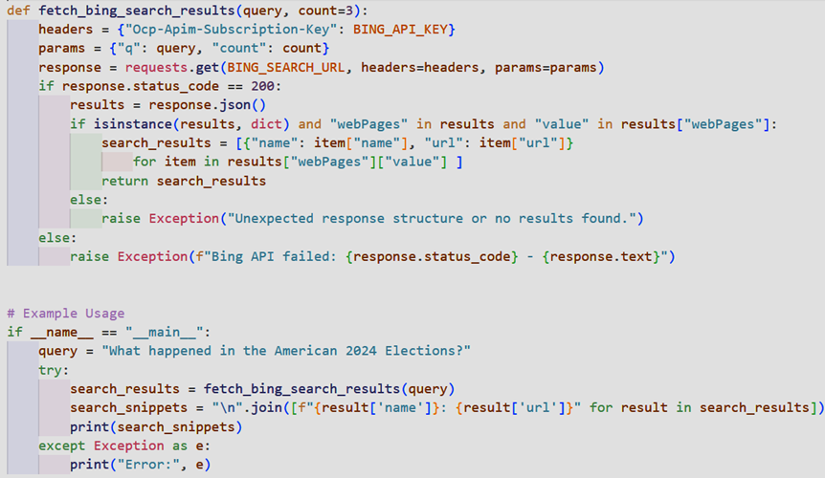

Figure (): Connection to Bing Search Engine

Figure 23 illustrates the terminal when running the code file

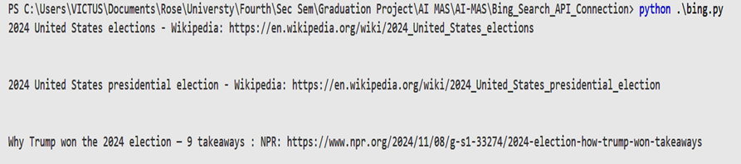

Figure (): Bing Connection Code Terminal

Then, we start to connect to the Falcon LLM API, Falcon is one of the HuggingFace models, and we select it quite randomly. The goal of this step is to understand how to connect to a LLM API providing a simple prompt and retrieving the model’s response.

Connecting to Falcon model is in the same manner we connect to Bing search engine, using the model API and an API key, providing the query in code. The result of running the Falcon Connection code in the terminal is as shown in figure 24.

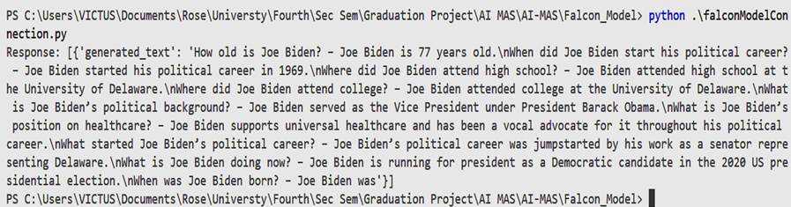

Figure (): Falcon Connection Code Terminal

The next step is connecting the Falcon API to Bing API. At this phase, no user interactivity is involved, the query is still in code, the query is sent to the Falcon API, Falcon queries the Bing API as a search engine, related web pages are retrieved and fed back to the Falcon Model API, Falcon Model uses these web results in addition to the user query for a better and up-to-date response. A screenshot of the terminal when running the Falcon to Bing connection code file is shown in figure 25.

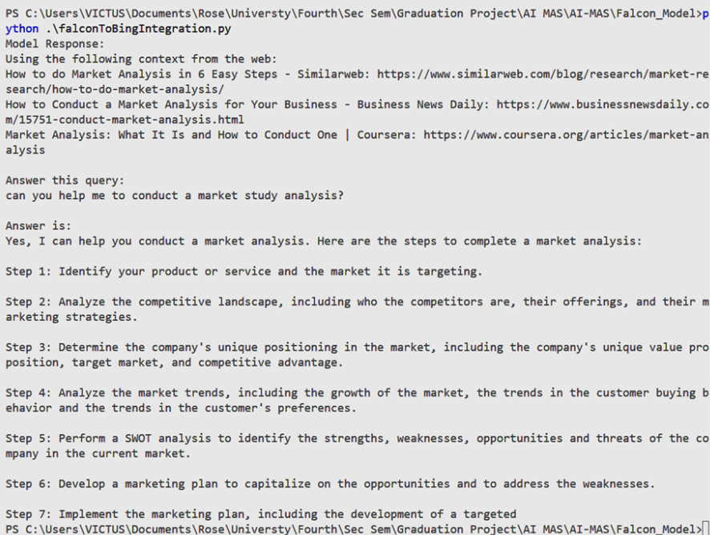

Figure (): Falcon to Bing Integration Terminal

## 6.2 Testing the Retrieval Process

At this stage, the prototype does not include a structured user interface or advanced prompt engineering. The code focuses solely on querying the Search Engine API with basic questions, retrieving results, and feeding those results directly into the LLM. The core aim is to observe how the system handles raw search engine results and how it can generate a coherent response by feeding this data into the model.

We experiment with a variety of queries to simulate real-world market analysis scenarios. For example, we input simple questions like, "What are the current trends in the Arabian Gulf retail market?" or "Who are the competitors in the Arabian Gulf agriculture sector?" or "What are the steps to conduct a market study analysis?" The search engine returns results, and these results are then passed directly to the LLM, which attempts to generate a response based on the search results.

While the initial prototype does not include any complex user interface or detailed prompts, this step is crucial for identifying the basic functionality of the retrieval system. The results highlight the need for further refinement of the process, particularly in terms of how the search results are parsed and presented to the LLM. In some cases, the search results are too broad, and the LLM struggles to extract meaningful insights from them without additional guidance.

One of the major challenges we encounter is how to handle and process the raw search engine results before feeding them into the LLM. The results often include a mix of unrelated information, advertisements, and overly general content. This makes it difficult for the LLM to differentiate between useful, relevant data and irrelevant noise.

## 6.3 Evaluating the System's Performance

The focus of this prototype is not on delivering polished results but on evaluating the viability of the process. The initial tests show that the system can successfully retrieve information from the web and generate relevant responses based on this data. There is no user interface to guide the flow of the interaction, but rather the query is inserted in code, and the LLM generates answers based on simple, raw search results, which sometimes lead to less accurate or overly broad responses.

Despite these limitations, the prototype allows us to gain critical insights into the retrieval process. It highlights key challenges in handling search engine results and gives us a clearer understanding of the steps needed to refine the system. In particular, it becomes evident that further steps will be necessary to refine how results are retrieved, filtered, and presented to the LLM in order to improve the accuracy and relevance of the final output.

## 6.4 Conclusion

The initial prototype development focuses on testing the core functionality of the system by connecting the LLM and Search Engine API. Without focusing on the user interface or custom prompts, we are able to validate the process of real-time data retrieval and response generation. While the prototype is basic, it provides valuable insights into how the search engine results are handled and how the LLM can generate meaningful answers based on this data. The next phase of development will involve refining these processes, including the handling of search results, the use of custom prompts, and the creation of a user-friendly interface to guide users through the market analysis process.

After defining the core functions of the chatbot, the next step is to design its user interface. A clear and simple UI helps users interact with the system smoothly, enter their details, and get market insights without confusion.

Chapter 7 explains how the chatbot’s interface was built using Gradio, why this tool was chosen, and how the design was improved to make the chatbot more user-friendly. It covers the basic components, like the input field, response area, and reset button, which help users communicate smoothly with the chatbot.

# Chapter 7 Design and User Interface

**Chapter 7  
Design and User Interface**

This chapter describes the design and development of the chatbot’s user interface. The goal is to create an interactive and user-friendly system that enhances usability and engagement.

This prototype prioritizes functionality over design. The primary goal is to develop a working system that effectively retrieves and processes market data rather than focusing on aesthetic elements or advanced UI components. The interface is minimalistic, serving as a practical tool for user interaction and system testing.  
Since this is a prototype, the system does not include a database or user authentication features such as login and registration. The focus is on demonstrating the chatbot’s core functionality rather than implementing full-scale user management.

## 7.1 Initial Design Using Gradio

The first version of the chatbot interface is built using [Gradio](https://www.gradio.app/). Choosing Gradio simplified the process of building the chatbot interface, it provided an easy way to integrate the model, allowing us to create a chat-based experience for the users where they can move through the analysis process step by step. This allows quick deployment of a web-based interface where users can input market-related details such as geographical location, sector, proposed value, customer segments. The chatbot returns real-time market insights, including market size, marketing trends, SWOT analysis, competitor analysis, and customer segmentation. The initial design prioritizes simplicity, focusing on core functionality over advanced features. At this stage, the only objective at this level is to provide a Gradio UI that simulates a chatbot, regardless of the performance and optimization, as shown in figure 26. The system shows a chatbot interface that connects to the LLM API which is integrated to the search engine API.

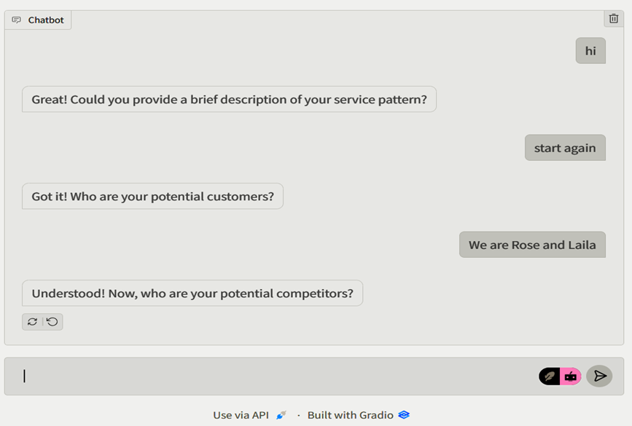

Figure (): First Gradio Interface

## ****7.2 Enhancing Design and User Interactivity****

After ensuring that the LLM API and search engine API integration works fine, and the initial Gradio interface was sufficient for the system purposes, ensuring flexible and smooth conversation between the model and the user, the next step is to enhance the design, providing more components to ensure a natural engagement with the chatbot.

**Key components of the interface:**

* Input Field: A text box where users could type their responses.
* Send Button: Located next to the input field, the send button was important for user interaction. For a better user experience, the Enter key in the keyboard is designed to function as send.
* Trash Button (Reset Button): To allow users to restart the conversation if they wanted to change their input or start fresh.
* Response Area: This section was responsible for displaying the chatbot’s replies in real time.
* Backend Integration: The chatbot had to process user inputs, send them to the LLM API, and return responses quickly.

By the end of this phase, we had a fully chatbot interface with an interactive chat window, input handling, and a reset feature. This provided a strong foundation for the next phase, where we would refine the chatbot’s structured prompts and integrate the LLM, search engine API, and Gradio interface into a single system. Figure 27 shows the final interface design.

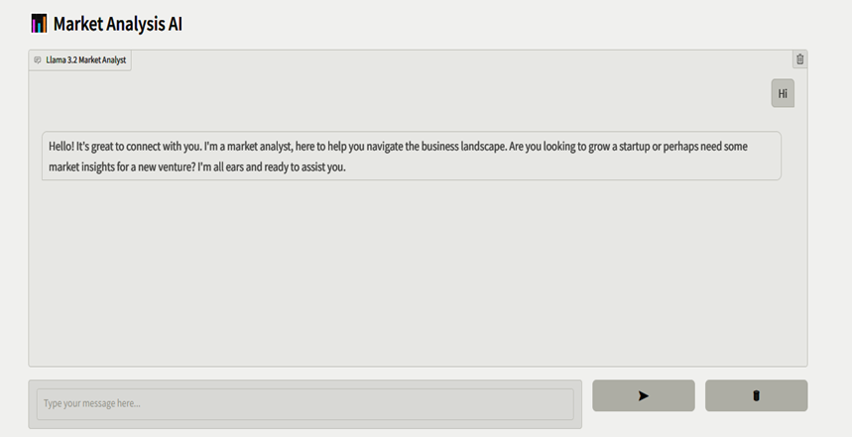

Figure (): Final Prototype Gradio Interface

# Chapter 8 Prototype Development: Testing and Refinement

**Chapter 8  
The Prototype Development: Testing and Refinement**

This chapter describes the process of developing, testing, and refining the prototype of the chatbot. The objective is to implement a functional version of the system and improve it gradually based on testing results.

The process followed an iterative and incremental approach, where each iteration focused on a specific functional requirement, involving development and testing. Each iteration built upon the previous one, adding new functionality and improving the system progressively. Table 6 below presents a brief summary of the iterations of the prototype development process.

Table : Prototype Development Iterations Summary

|  |  |
| --- | --- |
| Iteration | Description |
| First Iteration | Initial prototype implementation focusing on integrating the LLM API and search engine API, ensuring successful connection, web result retrieval, and coherent API integration. |
| Second Iteration | Integration of a Gradio chatbot interface, allowing user interaction. Focusing on connecting the chatbot UI with the LLM API and search engine API. Conduct unit and integration testing. |
| Third Iteration | Implement chatbot memory to maintain conversation history and provide a structured conversation flow. Enhance search engine API integration for real-time market data retrieval. Conduct system testing. |
| System Testing | Perform thorough testing using real-world scenarios to evaluate model accuracy, efficiency, and response relevance. Ensure project goals and requirements were met before final approval |

## 8.1 First Iteration: Initial Prototype Implementation

The first prototype implemented in a previous phase integrates the LLM API and search engine API regardless of design and interfaces.

This iteration focuses on ensuring a coherent APIs integration, and a successful relevant web results retrieval.

The process in detail is explained in the sixth chapter of this proposal.

This simple initial iteration also followed an iterative approach. First, we connect to the Bing API and perform unit testing, ensuring successful connection and web results retrieval.

Then, we connect the Falcon API, also performing unit testing to test the model’s capability to get the user query and interpret it.

The next step is performing integration testing, ensuring a successful integration between the system APIs.

## 8.2 Second Iteration: Chatbot Interface Integration

At this iteration, the initial prototype is integrated with a Gradio interface. The system allows users to input market-related details through a conversational chatbot interface.

This prototype has minimal features, it connects the chatbot’s interface to the LLM API, and the LLM API is capable of querying the search engine and retrieving web results through the search engine API. At this iteration of development, we do not provide a prompt. In addition, the model is not intelligent enough to interpret the user inputs.

One primary purpose of this phase is to ensure a successful integration of the system components, the Gradio interface, the LLM API, and the search engine API. Another objective of this phase is to ensure that the system is capable of reading the user inputs and providing a relevant result search.

The process in details is provided in chapter 7. And as the seventh chapter illustrates, the design process follows an iterative approach. The design phase starts with a basic design, using the Gradio built-in functions and components to build a chatbot interface, The chatbot was designed using Gradio’s Blocks and Chatbot components. The next iteration connects the UI to the backend, ensuring a coherent integration between all the system components. Furthermore, iterations are carried out at the design phase to enhance the UI to maintain a better user experience.

Testing at this iteration follows a similar manner to the previous iteration. We perform unit testing for each individual system component, including the APIs and the Gradio Interface.  
Then, we perform integration testing, to ensure coherent integration and connection between all the system components.

## 8.3 Third Iteration: Chat History

With both the LLM and the search engine API successfully integrated together, and the chatbot interface functions in a supportive manner, the next step is to ensure that not only the Gradio design is integrated to the backend, but also the system’s memory and chatbot history is good. This is a critical point, especially when considering that the model is incapable of providing a market analysis study sufficiently until it gets all data required, and for a better usability, we structure this process in a chat-base manner rather than requesting the user to provide all details in a single message. Chatting with the model as a user, means providing additional information each sent message, and the system needs to memorize the session information. In brief, the chatbot has to ensure a conversation flow by remembering past responses, ensuring that the conversation felt connected.

The first part of this phase focuses on linking the Llama 3.2 11B Vision model with the Gradio chatbot interface. The core function is responsible for handling user interactions, processing incoming messages and maintaining a structured chat history. When a user sends a message, the chatbot retrieves the chat history, appending the last sent message, formats the history appropriately, and sends it to the LLM for processing. The LLM then generates a response, which is displayed in the chatbot UI. Figures 28 and 29 show how the conversation is passed to the LLM.

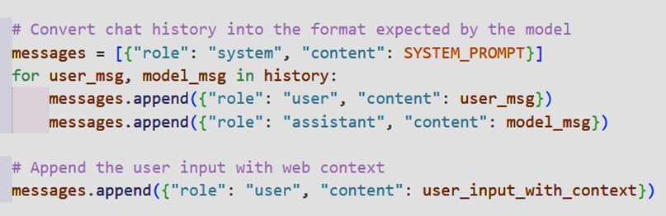

Figure (): Convert Chat History into The Format Expected by The Model

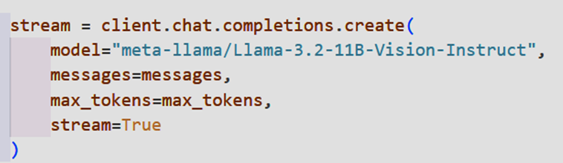

Figure (): Sending Formatted Conversation to The Model for Processing

Meanwhile, we need to enhance the search engine API integration, so that a real-time search can be performed to fetch market data. The integration with the LLM API is successful when querying a single message or question in previous development iterations. Now the system has to ensure that the search engine API is fed with the whole chat history for a successful integration. Up until this point in this iteration, the chatbot relies on the LLM’s internal knowledge. The integration process involves defining a function that enables the LLM to send API requests to Bing search engine, request is a formatted message containing the user’s business details. Once the search results are retrieved, and fed back to the LLM, another function processes the data by selecting the most relevant snippets from the top three results. These snippets are then fed into the LLM as additional context, ensuring that its analysis incorporates real-world competitor insights. Figure 30 shows the usage of Bing search API.

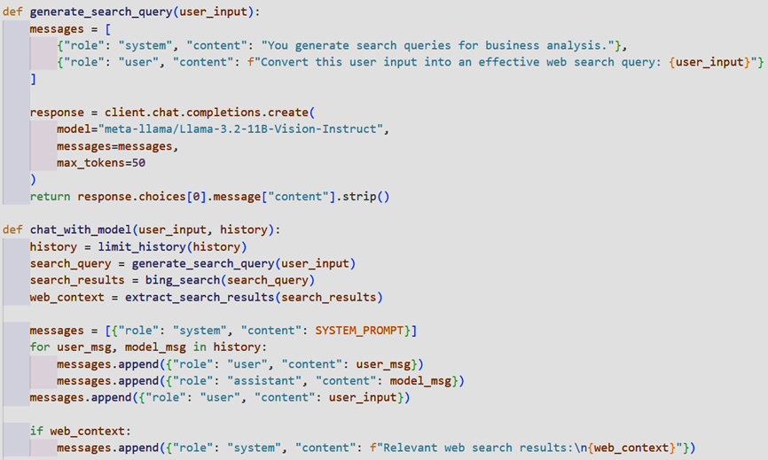

Figure (): Performing Bing Search on User’s Inputs

By the end of this phase, we had a fully integrated system where users could naturally interact with the chatbot, with real-time web search results that are provided to the model.

Testing at this iteration, in addition to unit and integration testing performed in the previous iterations, we perform system testing, which requires running the system code, trying different use cases and scenarios, to ensure the model capability of memorizing user inputs through the chat, and provide relevant search results.

## 8.4 System Testing

After completing the development process, where each stage included testing and improvements to implement in the next phase, the model is tested thoroughly using different cases and examples. These tests aim to check how well the model understands inputs, how accurate its responses are, and how efficiently it processes information. Various real-world scenarios are used to see how the model performs in different situations. If any issues are found, adjustments were made to improve its accuracy and reliability. After ensuring that the model met all the project’s goals and requirements, it was approved by us.

# Chapter 9 Experiments

**Chapter 9  
Experiments**

This chapter presents the experimental processes that we went through to optimize the performance of the chatbot. The experiments focus on four key aspects: a comparative testing of some GPT models to assess their capabilities in generating market insights, selecting the most suitable LLM for market analysis, evaluating the effectiveness of different search engine APIs for real-time data retrieval, and finally refining the prompt development process for the LLM.

The goal of these experiments is to refine the overall system, ensuring that the chatbot provides users with reliable business results.

## 9.1 Testing Existing GPTs efficiency to conduct Market Analysis Study:

To evaluate the effectiveness of existing GPT models in performing market analysis, we conduct tests using a structured instructional prompt. The objective is to determine how well these models understand user input and generate relevant market insights based on real-time data retrieval. We ensure a consistent and objective comparison of the GPTs for the same criteria. They are tested using a prompt that simulates a real-world market research scenario, requiring them to ask structured questions, remember user-provided responses, and generate market insights.

The key reasons for testing different GPT models was to explore how existing AI systems handle the same problem our chatbot is supposed to solve. By providing each model with the same prompt, we aimed to assess how well they generate competitor analysis and whether they follow a structured approach. This process helped us understand the strengths and limitations of current systems.

### 9.1.1 The Instructional Prompt Used for Testing GPT Models (First Testing Prompt)

The following prompt shown in figure 36 is initially provided to each of the GPTs that are used for testing.

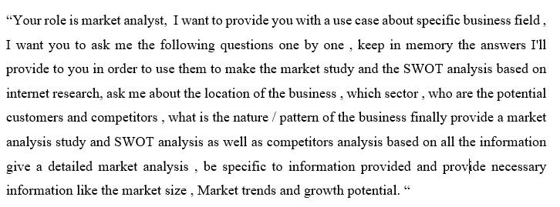

Figure (): Instructional Prompt for Testing GPT Models (First Testing Prompt)

Table 7 below shows the evaluation criteria of different GPTs for market analysis tasks for the first prompt.

Table : GPTs Testing Criteria for the Initial Testing Prompt

|  |  |  |
| --- | --- | --- |
| Criteria | Scale | Description |
| Market Analysis Depth | Low | The analysis provides a basic overview of the market, including market size and growth potential. |
| Market Analysis Depth | Medium | The analysis provides a more detailed overview of the market, including market size, growth potential, market trends, and key drivers. |
| Market Analysis Depth | High | The analysis provides a comprehensive overview of the market, including market size, growth potential, market trends, key drivers, and competitive landscape. |
| User Interaction | Excellent | The interaction flow was exactly as instructed. Questions were asked in the correct order, and the response was clear, concise, and detailed where appropriate. |
| User Interaction | Good | The flow was easy to follow and mostly aligned with instructions. Some responses were slightly more detailed or lengthy than needed but still clear and logical. |
| User Interaction | Acceptable | The interaction followed most of the intended instructions but included extra details. |
| Competitor Analysis | Excellent | Comprehensive analysis with specific competitor names, descriptions of their businesses |
| Competitor Analysis | Adequate | Mentioned competitor names but did not provide sufficient details about their business operations or strategies. |
| Competitor Analysis | Basic | General overview of competitors without naming specific ones. Limited depth and relevance in the analysis |

Moving on, the actual evaluation of the GPTs performance in market analysis tasks for the initial prompt is shown in table 8 below.

Table : Evaluation of GPT Models' Performance for Market Analysis Tasks - First Testing Prompt

|  |  |  |  |  |
| --- | --- | --- | --- | --- |
| Comments | Competitor  analysis | User interaction | Market Analysis Depth | Model |
| Logical result but it’s general, the same result can be used for other regions of the same use case | Basic | Excellent | Low | **Gpt-4o mini** |
| Correct results and SWOT points served the user case logically, but wasn’t tailored to the specified region | Adequate | Excellent | Medium | **Llama 3.1 70B** |
| Flow wasn’t as expected, provided the final result before asking the rest of the questions | Adequate | Acceptable | Medium | **Mistral 8x7B** |
| Didn’t provide SWOT and competitor analysis for the initial analysis result, asked questions that should be provided in the final result, didn’t instantly provide the analysis study, you have to ask it to provide it once again | Basic | Good | Low | **PI AI** |
| Logical results but general, not specified for the user’s entered region | Basic | Excellent | Medium | **Gemini** |
| Provided recommendations  For the business | Excellent | Excellent | High | **ChatGPT** |

### 9.1.2 The Instructional Prompt Used for Testing GPT Models (Final testing prompt)

After evaluating the GPTs with the initial prompt, we move on to testing them using the final system prompt, shown below in figure 37:

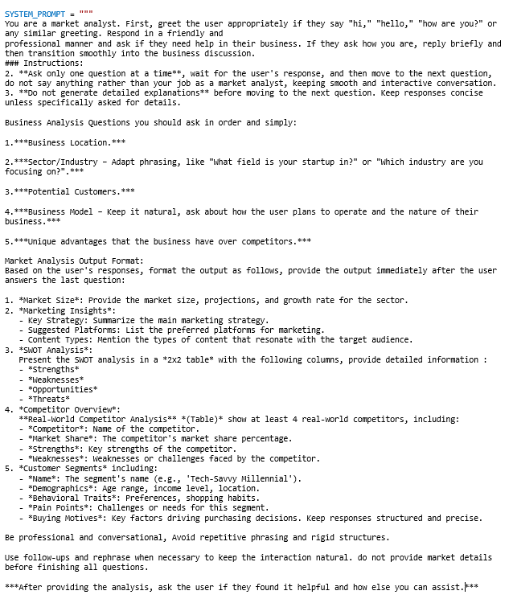

Figure (): Instructional Prompt for Testing GPT Models (Final Testing Prompt)

The criteria that we use to evaluate the GPTs for the final prompt focuses on user interaction and how well-structured the final output is, unlike the initial prompt, the final prompt includes detailed instructions for how the output must be formatted**,** so we assess how accurately each model follows these specific guidelines. In contrast**,** the evaluation criteria for the initial prompt are specific to it, as we assess how much detail each model can provide on market analysis and competitor insights without being explicitly guided to include specific details or structure.

Table 9 below shows the criteria used for assessing the GPTs for the final prompt:

Table : GPTs Testing Criteria for the Final Testing Prompt

|  |  |  |
| --- | --- | --- |
| Criteria | Scale | Description |
| Clarity of Final Output | Excellent | Well-structured, follows expected format, clear and organized insights, no redundant or missing information. |
| Clarity of Final Output | Good | Mostly follows expected structure with minor deviations. Some parts may be slightly wordy or condensed, but overall clarity and organization remain strong. |
| Clarity of Final Output | Acceptable | Some sections of the final output are missing, or the output structure lacks formatting as required. |
| Consistency in Questioning | Excellent | Follows the exact question sequence, never skips or reorders questions, and maintains a smooth flow. |
| Consistency in Questioning | Acceptable | Follows the intended structure but sometimes skips a question or asks them in a slightly different order. |
| Consistency in Questioning | Needs Improvement | Frequently ignores the intended question flow and skips critical questions. |

The evaluation of the GPTs performance in market analysis tasks for the final prompt is shown in table 10

Table : Evaluation of GPT Models' Performance for Market Analysis Tasks - Final Testing Prompt

|  |  |  |  |
| --- | --- | --- | --- |
| Comments | Consistency in Questioning | Clarity of Final Output | Model |
| Output was structured and detailed as required | Excellent | Excellent | **Gpt-4o mini** |
| Provided all required market insights but it was not structured. | Excellent | Acceptable | **Llama 3.3 70B** |
| Output was structured and detailed as required | Excellent | Excellent | **Mistral Small 3** |
| Did not provide complete study as required, market size was not specified, didn’t instantly provide the analysis study, you have to ask it to provide it once again | Excellent | Acceptable | **PI AI** |
| Competitor analysis and customer segments were missing | Excellent | Acceptable | **Gemini** |
| Output was structured and detailed as required | Excellent | Excellent | **ChatGPT** |

## 9.2 Evaluation of Large Language Models:

This section focuses on evaluating different Large Language Models (LLMs) to determine the most suitable one for the market analysis chatbot. The evaluation focuses on assessing their general response quality using general questions. To fairly compare response speed, we instructed all models for their responses to be within 100 words.

Evaluating different large language models before integrating one into the chatbot was a crucial step to ensure effectiveness. Since the chatbot's main role is to provide structured, insightful market analysis, the chosen LLM needed to generate clear and well responses.

The difference between this section and section 9.1 is that the first section evaluates how pre-built chatbot interfaces handle given prompts, and assessing their ability to generate a comprehensive market analysis, it helps to determine how well general-purpose AI chatbots perform in structured business research tasks. While this section focuses on selecting the most suitable LLM model (based on the mentioned criteria) for direct integration into our Python application.

### 9.2.1 Testing Different Large Language Models

To determine the best option, we tested different models based on the factors describes in table 11:

Table : LLM APIs Evaluation Criteria

|  |  |  |
| --- | --- | --- |
| Criteria | Scale | Description |
| Speed of Response | Fast | The model responds almost instantly, with negligible wait time. |
| Speed of Response | Moderate | The model responds quickly, with only a slight delay compared to "Fast" models. |
| Speed of Response | Slow | The model takes a noticeable amount of time to respond, requiring patience for longer or more complex queries. |
| Answers Breadth | Extensive | The model offers a highly detailed and nuanced answers. |
| Answers Breadth | Detailed | The model provides a more comprehensive response, including additional relevant details but without going too deep into the topic. |
| Answers Breadth | Basic | The model provides a direct or minimal response without much detail or elaboration. |

Table 12 presents a comparison of the evaluated LLMs given the previous criteria.

Table : LLM APIs Evaluation

|  |  |  |  |  |  |
| --- | --- | --- | --- | --- | --- |
| Model | Provider | Free Limit | Speed of Response | Latest Knowledge Cutoff | Answers Breadth |
| Gemma 2 9B Instruct | Hugging Face | 1000 requests/day | Slow | 2023 | Basic |
| Llama 3 8B | Hugging Face | 1000 requests/day | Fast | 2023 | Extensive |
| Llama 3.2 11B Vision | Hugging Face | 1000 requests/day | Moderate | 2024 | Detailed |
| Llama 3.2 3B | Hugging Face | 1000 requests/day | Fast | 2023 | Detailed |
| Mistral 7B Instruct | Hugging Face | 1000 requests/day | Fast | 2023 | Detailed |
| Zephyr 7B Beta | Hugging Face | 1000 requests/day | Moderate | 2021 | Extensive |
| Gemma-2-2b-it | Hugging Face | 1000 requests/day | Fast | 2023 | Detailed |
| Qwen/Qwen2.5-Coder-32B-Instruct | Hugging Face | 1000 requests/day | Moderate | 2023 | Detailed |
| deepseek-ai/DeepSeek-R1-Distill-Qwen-32B | Hugging Face | 1000 requests/day | Slow | 2024 | Extensive |
| Vikhrmodels/QVikhr-2.5-1.5B-Instruct-r | Hugging Face | 1000 requests/day | Slow | 2023 | Detailed |
| Gemini 2.0 Flash | Gemini | 15 requests/minute 1500 requests/day | Fast | 2024 | Detailed |
| Gemini 1.5 Flash-8B | Gemini | 15 requests/minute 1500 requests/day | Fast | 2023 | Basic |
| Gemini 1.5 Pro | Gemini | 2 requests/minute 50 requests/day | Fast | 2023 | Basic |
| Microsoft Phi-4 | OpenRouter | 20 requests/minute 200 requests/day | Moderate | 2023 | Detailed |
| Qwen VL Plus | OpenRouter | 20 requests/minute 200 requests/day | Fast | 2023 | Detailed |
| Qwen: Qwen2.5 VL 72B Instruct | OpenRouter | 20 requests/minute 200 requests/day | Moderate | 2023 | Detailed |
| Rogue Rose 103B v0.2 | OpenRouter | 20 requests/minute 200 requests/day | Moderate | 2023 | Detailed |
| Toppy M 7B | OpenRouter | 20 requests/minute 200 requests/day | Fast | 2021 | Detailed |

### 9.2.2 Examples for Extensive, Detailed and Basic answers while testing the models:

To illustrate the varying breadth of responses generated by different LLMs. As part of the evaluation, we examined how some models provide extensive answers with in-depth details, while others offer more concise but informative responses, and some generate only minimal, basic answers. These examples shown in table 13, highlighting the differences in response depth, demonstrating how each model presents information:

Table : Answer Depth Levels of Different Models

|  |  |  |
| --- | --- | --- |
| Model | Answer Depth | Answer |
| Lama 3 8B | Extensive | No, France is not the largest country in the world.  In fact, it is the 36th largest country in the world by land area, with a total area of approximately 551,500 square kilometers (213,000 square miles).  The five largest countries in the world by land area are:  1. Russia - 17,125,200 square kilometers (6,612,100 square miles)  2. Canada - 10,085,000 square kilometers (3,900,000 square miles)  3. China -9,712,967 square kilometers (3,755,794 square miles)  4. United States -9,161,928 square kilometers (3,537,438 square miles)  5. Brazil -8,514,877 square kilometers (3,288,000 square miles)  France, on the other hand, is a significant country with a rich culture, history, and economy, but it is relatively small compared to other countries. |
| Mistral 7B Instruct | Detailed | No, France is not the largest country in the world. In terms of land area, France is the 42nd largest country.  The largest country in the world is Russia, followed by Canada, China, and the United States. |
| Gemini 1.5 Flash-8B | Basic | No, France is not the largest country, Russia is. |

### 9.2.3 Final Decision:

At first, we have reached to a conclusion that **Llama 3 8B** is the most fitting model for our system, due to its fast and extensive performance compared to the other tested models, but later, it started to provide unreasonable responses as shown below in figures 38 and 39:

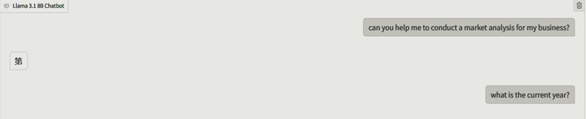

Figure (): Llama 3 8B Response Issues – pt 1

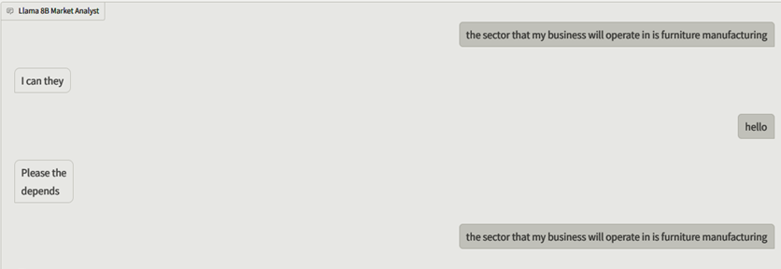

Figure (): Llama 3 8B Response Issues – pt 2

Due to that issue, we had to choose the closest model to **Lama 3 8B**, we finally decided to choose **Llama 3.2 11B Vision** because it delivers well-structured and insightful answers, making it a suitable choice for market analysis, provides one of the most recent knowledge cutoffs among available models and it follows multi-step instructions well.

## 9.3 Evaluation of Search Engine APIs:

After implementing the initial prototype, we need to choose a reliable search engine API to ensure the chatbot retrieves accurate and relevant market analysis insights. The chatbot relies on real-time data, so the chosen search engine must deliver precise results quickly while supporting a reasonable number of queries per month.

### 9.3.1 Evaluation of Search Engines

We considered and tested five different search engines: Bing, Google Custom Search (GCS), SERP API, DuckDuckGo, and CORE. Each of these was evaluated based on their performance and suitability for our chatbot.

To determine the best option for our case, we tested different search engines based on the factors shown in table 14:

Table : SE APIs Evaluation Criteria

|  |  |  |
| --- | --- | --- |
| Criteria | Scale | Description |
| Performance | High | The SE API responds with accurate and comprehensive search results, providing valuable information and market indicators. |
| Performance | Medium | The SE API responds with good results, but still can respond more professionally or lack advanced features. |
| Performance | Low | The SE API responds with not related results, or not even responding. Low Performance APIs were excluded from the comparison, as they are too much, and not making sense to use. |
| Relevance to Our Work | High | The SE API searches web sources related to market analysis and business. |
| Relevance to Our Work | Medium | The SE searches for less relevant sources, like academic papers. |
| Relevance to Our Work | Low | The SE API does not search related websites in most cases. |

Now, table 15 below, presents our evaluation to the five SE APIs, given the criteria described in table 14.

Table : Search Engine APIs Evaluation

|  |  |  |  |  |  |  |
| --- | --- | --- | --- | --- | --- | --- |
| Search Engine | Limitations | Free Limitation | Performance | Relevance To Our Work | Notes | Our Rating  (1-5) |
| Bing | Offers multiple tiers, prices for 1000 calls ranges between 15$ to 25$ | 3 call/second,  Limited to 1000 calls/month,  “Student usage/ the free tier”  It also provides 2 different keys, which can be regenerated at any time. | High | High | Reliable results; easy integration; offers image, video, and news search | 4.5 |
| Google Custom Search  GCS | 10,000 queries/day,  5$ per 1000 queries | 100 query/day free limit. requires billing information for higher usage | High | High | Setup requires API key and search engine API. Limited free queries but highly accurate and comprehensive results. | 4 |
| SERP API | Offers multiple tiers, plans offerings range from 5,000 to 100,000 calls/month. Prices ranges from 75$ to 725$ per month | 100 calls/month | High | High | Only focusing on scraping search results, which may not provide the depth or relevance, as it doesn’t interpret or analyze the data.  Handles CAPTCHAs; supports multiple search engines  Very good to collect data from multiple search engines | 3.5 |
| Duck Duck Go | Open without limits | Free | Medium | Medium | No API key required. Good for privacy but lacks advanced features. Less performance compared to others | 3 |
| CORE | Open without limits | Free | High | Low | No API key required. Good for academic research but less suited for business analysis., and therefore is less relevant for our subject  (Focused on academic and open-access research) | 2 |

### 9.3.2 Final Decision

After testing and evaluating these options, **Bing** is selected as the best search engine API for our chatbot. It provides a balance between query limits, cost, relevance, and performance. The chatbot can efficiently retrieve market insights with high accuracy while maintaining reasonable costs and billing structure. Additionally, Bing’s structured responses help simplify the processing of retrieved data.

Going forward, we will monitor API performance, explore query optimization techniques, and remain open to switching APIs if a better option arises. This ensures our chatbot remains efficient and provides high-quality market insights to users.

## 9.4 Prompt Development:

The process of system prompt development requires multiple iterations to refine the prompt and achieve the level of depth we want.

### 9.4.1 The initial prompt: A simple market analyst role:

We initially design the prompt to be straightforward, instructing the model to act as a market analyst, ask the user some market-related questions and generate the final market insights. At this stage the model is functional but it is generic and unstructured, it lacks depth in questions about the business, and the interaction flow is static rather than interactive. Below, figure 40 shows a conversation with the chatbot having this initial prompt:

|  |
| --- |
|  |

Figure (): Chatbot Conversation with Initial Prompt

### 9.4.2 Second Prompt: Defining Key Business Components

We realized that the system needs to ask more strategic questions to collect more details about the user’s business, we expand the prompt to make the questions more structured, we add key components into the prompt to make sure the model asks about the location of the business, the sector or the industry of the business, potential customers and competitors and finally how the business will operate. With this enhancement, the model goes beyond generic analysis and generates the response based on real-world factors, response included market size, SWOT analysis, and competitor analysis. However, the response still needs to be structured. Figure 41 below shows a conversation with the chatbot with the second prompt:

|  |
| --- |
|  |

Figure (): Chatbot Example – Second Structured prompt Development

### 9.4.3 Third Prompt: Introducing a Structured Output Format

We realize that even though the chatbot is now asking better questions, its final responses still lack a well-organized structure. The results are sometimes messy, and different conversations would lead to inconsistent formatting. To fix this, we introduce a standardized output format, instructing the model to always return its responses including the following:

* Market size and growth rate for the sector.
* Marketing insights and suggested marketing platforms.
* Content types that resonate with targeted audiences.
* SWOT analysis in table format.
* Competitor overview in table format that includes names of the competitors, their market share, their key strengths and weaknesses.
* Customer segments that include segment name, demographics, behavioral traits, pain points and buying motives.

This improvement greatly enhanced the clarity of the chatbot’s responses, but we still could do more improvement. While the chatbot was now structured, it sometimes lacked depth in questioning. We needed to make it more engaging and intuitive. Below, figure 42 shows the MAS provided by the chatbot with the third prompt:

|  |
| --- |
|  |

Figure (): Chatbot Example - Third Structured Prompt Development

### 9.4.4 Final Prompt Refinement: Enhancing the Flow, Tone, and User Experience

For the final step, we focus on the chat’s tone and flow to make it professional and conversational, we instruct it to avoid repetitive questions, keep the conversation natural, check user’s satisfaction after providing the final analysis and see if they need any further help, and finally to handle greetings and the beginning of the conversations naturally, for example if the user says ‘Hello’, it should greet them back instead of immediately start asking about the business. We also enhance the questions by adding new ones like unique advantages for the business, and we decide to let the model search and analyze competitors instead of letting the user research for them, facilitating this tough work for users.

The final refinement transforms the chatbot to be a more interactive, professional and user-friendly market analyst.

The development of the chatbot’s prompt is an iterative process. Starts as a basic instruction to act as a market analyst and gradually evolve into a structured and insightful market research assistant. Below, figure 43 shows a conversation with the chatbot with the final prompt, and the MAS provided by him:

|  |
| --- |
|  |

Figure (): Chatbot Example - Final Structured prompt Development

# Chapter 10 Use Cases and System Execution

**Chapter 10   
Use Cases and System Excecution**

This chapter presents the execution of the developed system in real-world scenarios. It includes specific use cases that demonstrate how the system operates based on different inputs and expected outputs. The objective is to validate the system’s functionality and illustrate its ability to generate meaningful results. Each use case outlines the input parameters, the execution process, and the obtained results.

## 10.1 Makkah Restaurant Market Analysis

**User:** Hello, can you help me to conduct a market analysis for my business?

**Chatbot:** I'm glad you're excited to conduct a market analysis for your business. To get started, I'd love to know more about your business. Can you please tell me what location your business is based in?

**User:** Location is Saudi Arabia, Makkah.

**Chatbot:** With Makkah being a significant Islamic pilgrimage site and a major urban center in Saudi Arabia, it has a unique market landscape. What field is your startup in, considering the local culture, economy, and industry trends in Makkah?

**User:** The business falls within the food sector.

**Chatbot:** That's a promising sector. Now, let's dive deeper. Who do you consider to be your potential customers in the food sector of Makkah? Are they pilgrims visiting for Hajj or Umrah, locals, or a mix of both?

**User:** Potential customers are local residents and tourists during worship times.

**Chatbot:** With your customer segment identified as local residents and tourists during worship times, now let's get into the operational aspect of your food business. How do you plan to operate your food business in Makkah - will it be via online delivery, dine-in at a physical location, or possibly through vending machines and carts?

**User:** The business will operate as a physical restaurant.

**Chatbot:** Now, let's focus on differentiating your physical restaurant business in the competitive food sector of Makkah. What unique advantages do you have over competitors that will attract and retain customers, such as signature dishes, unique dining experiences, or innovative marketing strategies?

**User:** Advantages include serving Arabic food instead of western dishes and creating an atmosphere that reflects Arab culture.

**Chatbot:** Here is your Market Analysis Output:

**Market Size**

The market size for the food sector in Makkah is estimated to be **around SR 11.3 billion (USD 3 billion) in 2023**, with a compound annual growth rate **(CAGR) of 5.3% from 2020 to 2025**. The increasing number of tourists and locals visiting Makkah for pilgrimage and worship, as well as the growing demand for local cuisine, drive this growth.

**Marketing Insights**

* **Key Strategy**: Focus on showcasing authentic Arabic cuisine, leveraging social media to promote unique dishes and cultural experiences, and partnering with local food influencers.
* **Suggested Platforms**: Utilize Instagram, TikTok, and Arabic-language social media platforms to target the local audience and promote the restaurant's unique offerings.
* **Content Types**: Share high-quality images and videos of dishes, behind-the-scenes kitchen moments, and customer testimonials to create an immersive experience.

**SWOT Analysis**

|  |  |  |  |
| --- | --- | --- | --- |
| ****Strengths**** | ****Weaknesses**** | ****Opportunities**** | ****Threats**** |
| Unique Arabic cuisine, authentic atmosphere | Limited marketing budget, competition from existing restaurants | Growing demand for local food, increasing tourism | Changing consumer preferences, economic fluctuations |
| Strong social media presence, customer loyalty program | Limited operating hours, seasonal fluctuations | Partnerships with local businesses, catering services | Regulatory changes, supply chain disruptions |

**Competitor Overview**

|  |  |  |  |
| --- | --- | --- | --- |
| ****Competitor**** | ****Market Share**** | ****Strengths**** | ****Weaknesses**** |
| McDonald's Makkah | 12% | Global brand recognition, wide menu offerings | Limited local flavor, high prices |
| Kudu Restaurant | 8% | Traditional Arabic cuisine, family-friendly atmosphere | Limited marketing efforts, outdated decor |
| Al-Tazaj | 5% | Unique shawarma offerings, quick service | Limited seating capacity, high prices |

**5. Customer Segments**

|  |  |  |  |  |
| --- | --- | --- | --- | --- |
| ****Segment**** | ****Demographics**** | ****Behavioral Traits**** | ****Buying Motives**** | ****Pain Points**** |
| **Local Foodies** | 25-45, middle-income, Makkah residents | Appreciate local cuisine, enthusiastic about trying new dishes | Flavor, aroma, cultural experience | Limited dining options, high prices |
| **Tourist Families** | 30-50, diverse backgrounds, visiting Makkah for pilgrimage | Desire authentic Arabic food, kid-friendly environment | Convenience, flavor, family-friendly atmosphere | Limited options, high prices |

## 10.2 Business Templates-Qatar Market Analysis

**User:** Hello!

**Chatbot:** Hello! It's great to connect with you. I'm a market analyst, and I'd be happy to help you with your business. Are you looking to launch a new product, service, or startup, and you need some expert guidance on market analysis and strategy?

**User:** I am launching a web platform that provides services. I need help to conduct my market analysis study.

**Chatbot:** With a web platform that provides services, let's dive deeper. What field is your startup in or what industry are you focusing on, such as finance, education, or healthcare?

**User:** We help users in business template preparation. I think our business falls within the business sector.

**Chatbot:** Great, so your web platform helps users with business template preparation, which falls under the business sector. Can you tell me more about your target audience? Who are the potential customers for your service?

**User:** My potential customers are students, entrepreneurs, SMEs and startup owners, Business and Management Colleges, and incubators.

**Chatbot:** Based on your target audience, which includes students, entrepreneurs, SMEs, startup owners, business and management colleges, and incubators, it seems like your web platform will cater to a wide range of users with varying needs. To clarify, it sounds like your platform will offer a mix of free and paid services to these users. Am I correct in assuming that your business model will involve generating revenue through a subscription-based model, perhaps with tiered pricing for different types of users (e.g., students, businesses), or potentially through premium templates or additional features?

**User:** We have 3 revenue streams: usage-fee, monthly subscription, and custom requests.

**Chatbot:** With three revenue streams in place, you have a solid foundation for generating income from your web platform. What sets your business apart from competitors in the business template preparation market? Do you have any unique advantages, such as proprietary template designs, innovative features, or exclusive partnerships with business schools or incubators?

**User:** Yes, rather than providing a comprehensive description and explanations of the business and business documents or just offering a template for users to fill out alone, we provide templates with minimal pre-knowledge required. We also include facilitating tips, notes, and examples to help users fill out each section.

**Chatbot**: Here is your Market Analysis Output:

**Market Size**

The global business planning software market is projected to reach **USD 13.8 billion by 2025**, growing at a **CAGR of 11.6%** during the forecast period.

**Marketing Insights**

* **Key Strategy:** Educate potential customers on the platform's value proposition, highlighting the benefits of using templates with facilitating tips and notes.
* **Suggested Platforms:** Leverage LinkedIn and Twitter to reach business students, entrepreneurs, and professionals. Use Google Ads to target relevant search queries.
* **Content Types:** Create informative blog posts, videos, and guides showcasing how the platform streamlines business template preparation. Share case studies and testimonials to build credibility.

**SWOT Analysis**

|  |  |  |  |
| --- | --- | --- | --- |
| Threats | Opportunities | Weaknesses | Strengths |
| Competition from established providers | Growing demand for business planning software | Limited scalability | Unique value proposition |
| Technical issues and update challenges | Partnerships with business schools and incubators | Relatively high pricing | User-friendly interface |

**Competitor Analysis**

|  |  |  |  |
| --- | --- | --- | --- |
| Competitor | Market Share | Strengths | Weaknesses |
| BizPlanBuilder | 25% | Comprehensive template library | Limited customization options |
| LivePlan | 20% | User-friendly interface | Relatively high pricing |
| Business Plan Pro | 15% | Robust features | Steep learning curve |

**Customer Segments**

|  |  |  |  |  |
| --- | --- | --- | --- | --- |
| Segment | Demographics | Behavioral Traits | Pain Points | Buying Motives |
| Tech-savvy entrepreneurs | Age 25-40, income $50,000+, urban location | Proactive, risk- tolerant | Time-consuming template creation | Ease of use, efficiency, and cost-effectiveness |
| Business students | Age 18-25, students, urban location | Motivated, goal- oriented | Limited access to resources, skills development | Educational value, user-friendly interface, and affordable pricing |

## 10.3 New York Clothing shop Market Analysis

**User:** Hello, can you help me to conduct a market analysis for my business?

**Chatbot:** I'd be happy to help with the market analysis for your business. Before we dive into the specifics, where is your business located, and which region do you primarily operate in?

**User:** The business will be based in New York City.

**Chatbot:** New York City is a great hub for businesses. Now, let's talk about your business. What field or industry is your startup in?

**User:** The business operates in the fashion industry, specializing in clothing sales.

**Chatbot:** I see you're in the fashion industry, with a focus on clothing sales. That's a highly competitive space. Who are the primary customers you're targeting with your clothing sales? Are you focusing on a specific demographic, such as young adults, professionals, or perhaps a specific age group?

**User:** Potential customers are fashion-conscious individuals and young professionals.

**Chatbot:** Fashion-conscious individuals and young professionals are a key demographic for the fashion industry. Now, can you tell me how you plan to operate your business - will you be selling online, in-store, or a combination of both?

**User:** The business will function as a physical store. It will generate revenue from direct clothing sales.

**Chatbot:** I've taken note of your business model. Next question - what unique advantages or selling points do you have that will set your physical clothing store apart from competitors in New York City, such as exclusive brands, personalized services, or something else?

**User:** Advantages include providing options like tailored fits or made-to-order pieces and offering unique, seasonal, or limited-edition clothing that is not available in other stores.

**Chatbot**: Okay here is Market Analysis Summary for Fashion Business

**Market Size:**

* **Total Market Size:** $361 billion (US Fashion Industry)
* **Projected Growth:** 4.2% annual growth (2023-2025)
* **Industry Trend:** Stable, with a rise in e-commerce and omnichannel retailing

**Marketing Insights:**

* **Key Strategy:** Emphasize experiential retail, focusing on tailored fits and made-to-order pieces to create a luxurious shopping experience.
* **Suggested Platforms:** social media (Instagram, TikTok), influencer marketing, and local events to showcase unique, seasonal, or limited-edition clothing.
* **Content Types:** High-quality product photography, 360-degree product views, and shoppable content to showcase exclusive designs.

**SWOT Analysis:**

|  |  |  |  |
| --- | --- | --- | --- |
| Strengths | Weaknesses | Opportunities | Threats |
| Exclusivity of tailored fits and made-to-order pieces, personalized services and expertise | Limited product selection for customers with custom fit challenges | Rise of experiential retail and influencer marketing | Over-reliance on trendy designs and limited-edition products |

**Competitor Overview:**

|  |  |  |  |
| --- | --- | --- | --- |
| Competitor | Market Share | Strengths | Weaknesses |
| Nordstrom | 5.6% | Wide selection, excellent customer service | Higher costs, limited online options for New York City market |
| Saks Fifth Avenue | 4.2% | Upscale shopping experience, unique designer collaborations | Pricing, limited target audience, high costs |
| AllSaints | 2.5% | Trendy designs, high-quality products, London influence | Limited availability in other markets, small scale |
| COS | 2.2% | Scandinavian designs, high-quality products, eco-friendly practices | Limited availability of seasonal designs, small scale |

**Customer Segments:**

|  |  |  |  |  |
| --- | --- | --- | --- | --- |
| Segment | Demographics | Behavioral Traits | Pain Points | Buying Motives |
| Fashion-Conscious Young Professional | 25-40 years old, high income, busy schedule | Fast-paced lifestyle, trend-consciousness, high aspirations | Lack of quality time for personalizing clothing, difficulty in finding exclusive designs | Style, comfort, elegance, and sustainability |

## 10.4 Gaza Tents Market Analysis

**Market Size:**

* The global temporary housing market, including caravans and tents, is projected to grow at a **CAGR of 4.5% from 2023 to 2028.**
* The market size is estimated to reach **$2.5 billion by 2028**.
* Demand is driven by humanitarian needs and emergency shelter requirements.

**Marketing Insights:**

* **Key Strategy:** Focus on partnering with NGOs and aid groups to increase outreach and credibility while maintaining an online presence to engage directly with potential customers.
* **Suggested Platforms:** Utilize Facebook, Instagram, and Twitter to share impact stories and raise awareness about the business.
* **Content Types:** High-quality images and videos of caravans and tents, along with testimonials from satisfied clients, to showcase product quality and effectiveness.

**SWOT Analysis:**

|  |  |  |  |
| --- | --- | --- | --- |
| Strengths | Weaknesses | Opportunities | Threats |
| Growing demand for emergency shelter solutions | Limited marketing budget | Potential partnerships with governments and international organizations | High operating costs |
| Waterproof tents and caravan offerings | Competition from established players | Political instability increasing temporary housing needs | Economic downturns reducing demand |

**Competitor Overview:**

|  |  |  |  |
| --- | --- | --- | --- |
| Competitor | Market Share | Strengths | Weaknesses |
| ShelterBox | 20% | Strong partnerships with NGOs, wide range of shelter solutions | Limited distribution channels, high costs |
| International Rescue Committee | 15% | Extensive network of partners, experienced team | Limited product diversity, high operating costs |
| Samaritan's Purse | 10% | Strong brand recognition, extensive resources | Limited distribution channels, high costs |
| CARE | 5% | Wide range of programs, strong NGO partnerships | Limited product diversity, high operating costs |

**Customer Segments:**

|  |  |  |  |  |
| --- | --- | --- | --- | --- |
| Segment | Demographics | Behavioral Traits | Pain Points | Buying Motives |
| Homeless Individuals | Age 18-64, low-income, unemployed | Seeking shelter, food, and clothing | Limited access to resources, stigma around homelessness | Urgency, affordability |
| NGOs and Aid-Groups | Age 25-65, middle to upper-income, humanitarian-focused | Seeking efficient, effective solutions for emergency shelter | High demand, limited resources | Reputation, cost-effectiveness |

# Chapter 11 Conclusions and Future Works

**Chapter 11  
Conclusions and Future Works**

## 11.1 Conclusion

This project successfully developed a prototype of an AI-powered chatbot that simplifies market research by providing users with market insights through a structured and interactive process. The system integrates an LLM with a real-time search engine, enabling it to gather and analyze market data, the chatbot ensures an easy experience while collecting necessary business details from the users through a guided conversation, which are used after that to generate a market analysis study, including SWOT evaluations, competitor insights, and market size estimations. The implementation of this solution achieved the project’s primary objective which is making market research more efficient and cost-effective. Users no longer need to explore complex reports to gather market data, instead, they receive structured and relevant insights with easy interaction with the chatbot. Achieving this goal was through project planning, including defining the project's scope, selecting the most suitable AI models and search engines after testing various options, developing a user-friendly interface with Gradio, and integrating Bing search with the LLM allowed the system to provide up-to-date information to enhance the results. Additionally, a structured prompt of instructions was successfully designed and provided for the model to improve user processing as well as a response format for the final market study.

This project has a significant impact on the IT and business sectors by demonstrating how AI can advance market research and business intelligence, with the evolution of AI-powered chat interfaces, showing that natural language interactions can simplify complex data analysis, to provide more intelligent, automated solutions in the IT and business industries.

## 11.2 Future Works

In the future, we plan to improve our chatbot by fine-tuning it with more relevant data. This will help make its answers more accurate and useful for users. We also want to train it on real business cases and allow it to learn from user inputs, while taking into account certain rules and guidelines. This way, the chatbot will provide more personalized and reliable recommendations.  
Once the chatbot is improved, we will integrate it into a website that provides pre-designed templates for various strategic planning frameworks, such as Business Model Canvas (BMC), strategic plans, operational plan, business plans, and feasibility studies.

The chatbot will assist users in filling out these templates by giving step-by-step guidance.   
We plan to enhance the system so that the core model is capable of processing all types of strategic plans requested by the user. This could involve designing the model with multiple specialized sub-models, each tailored to a specific type of plan. These sub-models would be seamlessly integrated into the system’s architecture, allowing the chatbot to efficiently address the unique requirements of various strategic planning processes.

# References

|  |  |
| --- | --- |
| [1] | S. A. Taha، المرشد في إعداد خطط الأعمال، Gaza، 2025. |
| [2] | R. Turner, "The Future of Market Research: How AI and Machine Learning Are Shaping the Industry," 17 10 2024. [Online]. Available: https://researchworld.com/articles/the-future-of-market-research-how-ai-and-machine-learning-are-shaping-the-industry. [Accessed 17 3 2025]. |
| [3] | D. S. Rose, The Startup Checklist: 25 steps to a scalable, high-growth business, 2016. |
| [4] | Francis J. Ggreene and C. Hopp, "Research: Writing a Business Plan Makes Your Startup More Likely to Succeed," 14 July 2017. [Online]. Available: https://hbr.org/2017/07/research-writing-a-business-plan-makes-your-startup-more-likely-to-succeed. |
| [5] | N. Grégoire, "Startup Failure Statistics: What Percentage of Startups Fail?," 2025. [Online]. Available: https://breznikar.com/article/startup-failure-statistics-what-percentage-of-startups-fail/2383. [Accessed 3 2025]. |
| [6] | "The Top 12 Reasons Startups Fail," 3 8 2021. [Online]. Available: https://www.cbinsights.com/research/report/startup-failure-reasons-top/. [Accessed 16 3 2025]. |
| [7] | L. Gallagher, The Airbnb Story: How Three Ordinary Guys Disrupted an Industry, Made Billions . . . and Created Plenty of Controversy, Houghton Mifflin Harcourt, 2017, 2017. |
| [8] | A. Twin, "How to Do Market Research, Types, and Example," 26 7 2024. [Online]. Available: https://www.investopedia.com/terms/m/market-research.asp?. [Accessed 10 2 2025]. |
| [9] | S. Kaushik, "The Rise of AI-Powered Competitive intelligence: Transforming Market Analysis," 2024. |
| [10] | S. K. Pattanayak, "Leveraging Generative AI for Enhanced Market Analysis," *Leveraging Generative AI for Enhanced Market Analysis: A New Paradigm for Business Consulting,* vol. 9, no. 9, 2021. |
| [11] | E. G. Carayannis, R. Dumitrescu, T. Falkowski and N. Rigert Zota, "Empowering SMEs “Harnessing the Potential of Gen AI for Resilience and Competitiveness”," *Empowering SMEs “Harnessing the Potential of Gen AI for Resilience and Competitiveness”,* p. 14755, 2024. |
| [12] | "Worldkraft.ai," 2024. [Online]. Available: https://wordkraft.ai/ai-writer/market-analysis-generator/?utm_source=chatgpt.com]. |
| [13] | "Statista," Statista, 2023. [Online]. Available: https://www.statista.com/. |
| [14] | "FounderPal.ai," FounderPal, 2025. [Online]. Available: https://founderpal.ai/swot-analysis-generator. |
| [15] | "DimeADozen.ai - AI Business Validation," Dimeadozen.ai, 2024. [Online]. Available: https://www.dimeadozen.ai/. |
| [16] | M. Wang, D. J. Zhang and H. Zhang, "Large Language Models for Market Research: A Data-augmentation Approach," Heng Zhang, 2024. |
| [17] | H. K. H. K. Felipe A. Csazar, "Artificial Intelligence and Strategic Decision-Making," *Artificial Intelligence and Strategic Decision-Making: Evidence from Entrepreneurs and Investors,* 2024. |
| [18] | L. Whiteling, START YOUR OWN BUSINESS 2010, Crimson Publishing, 2010. |
| [19] | S. Danby, "Business Model Canvas Explained: Definition, Pros, Cons, and Building Blocks," 7 4 2023. [Online]. Available: https://blog.invgate.com/business-model-canvas. [Accessed 1 2025]. |
| [20] | E. Gürel, "SWOT Analysis," *SWOT ANALYSIS: A THEORETICAL REVIEW,* vol. 10, no. 51, pp. 994-1001, 2017. |
| [21] | "SWOT Analysis Explained: Applications, Benefits, Example & Templates," 16 8 2022. [Online]. Available: https://oem.news/business/startup-basics/what-is-swot-analysis-how-to-perform-it-advantages-its-limitations/. [Accessed 12 2024]. |
| [22] | P. Gratton, "Porter's Five Forces Explained and How to Use the Model," 2024. [Online]. Available: https://www.investopedia.com/terms/p/porter.asp. |
| [23] | "STARTUP STRATEGY: 7 Frameworks All Startup Founders Should Use," 14 3 2022. [Online]. Available: https://startupanz.com/startup-strategy-7-frameworks-startup-founders-should-use/. [Accessed 12 2024]. |
| [24] | M. Danao, "Porter’s Five Forces: Definition & How To Use The Model," 2024. [Online]. Available: https://www.forbes.com/advisor/business/porters-five-forces/. |
| [25] | "What is an API (Application Programming Interface)," 2 2025. [Online]. Available: https://www.geeksforgeeks.org/what-is-an-api/. [Accessed 12 2024]. |
| [26] | C. A. Endalkachew Desta, "The Role of Artificial Intelligence on Market Performance: Evidence from Scientific Review," *The Role of Artificial Intelligence on Market Performance: Evidence from Scientific Review,* p. 83, 2024. |
| [27] | I. M. Enholm, E. Papagiannidis, P. Mikalef and J. Krogstie, "Artificial Intelligence and Business Value: a Literature Review," *Artificial Intelligence and Business Value: a Literature Review,* vol. 24, p. 1709–1716, 2021. |
| [28] | H. Wang, J. Huang and Z. Zhang, "The impact of deep learning on organizational Agility," in *the 40th International Conference on Information Systems (ICIS)*, Germany, 2019. |
| [29] | A. Bordas, P. LeMasson, M. Thomas and B. Weil, "What is generative in generative artificial intelligenc? A design-based perspective," *What is generative in generative artificial intelligenc? A design-based perspective,* vol. 35, pp. 427-438, 2024. |
| [30] | M. S. Cole Stryker, "What is Generative AI?," IBM, 22 3 2024. [Online]. Available: https://www.ibm.com/think/topics/generative-ai. [Accessed 12 2024]. |
| [31] | S. Ray, "Deep Dive into AI-Powered Marketing Analytics," *Deep Dive into AI-Powered Marketing Analytics,* vol. 14, no. 2, pp. 3-6, 2024. |
| [32] | "Natural Language Processing (NLP) – Overview," 12 2024. [Online]. Available: https://www.geeksforgeeks.org/natural-language-processing-overview/. [Accessed 1 2025]. |
| [33] | "What are Large Language Models?," IBM, 2 11 2023. [Online]. Available: https://www.ibm.com/think/topics/large-language-models. [Accessed 2 2 2025]. |
| [34] | "2024 perspective: the omnichannel trend in customer service," 2 2024. [Online]. Available: https://jiq.ai/blog/en/the-omnichannel-trend-in-customer-service. [Accessed 12 2024]. |
| [35] | J. Ferrara, "The benefits of implementing RAG in using LLMs," 25 11 2024. [Online]. Available: https://www.tonic.ai/guides/what-is-retrieval-augmented-generation-the-benefits-of-implementing-rag-in-using-llms. [Accessed 7 2 2025]. |
| [36] | S. Ahmed, "What is Retrieval-Augmented Generation(RAG) in LLM and How it works?," 22 4 2024. [Online]. Available: https://medium.com/@sahin.samia/what-is-retrieval-augmented-generation-rag-in-llm-and-how-it-works-a8c79e35a172. [Accessed 7 2 2025]. |
| [37] | "RAG vs Semantic Search: The AI Techniques Redefining Data Retrieval," 29 1 2024. [Online]. Available: https://www.webuters.com/rag-vs-semantic-search-the-ai-techniques-redefining-data-retrieval. [Accessed 2 2 2025]. |
| [38] | "IBISWorld - Industry Msrket Research, Reports, and Statistics," IBISWorld , 2024. [Online]. Available: https://www.ibisworld.com/. |
| [39] | "Mordor Intelligence," Mordor Intelligence, 2019. [Online]. Available: https://www.mordorintelligence.com/. |
| [40] | "Market Research Reports & Consulting | Grand View Research," Grand View Research, 2024. [Online]. Available: https://www.grandviewresearch.com/. |
| [41] | "Euromonitor International | Strategic Market Research, Data & Analysis," Euromonitor International , 2023. [Online]. Available: https://www.euromonitor.com/. |
| [42] | "MyMap.AI," MyMap.AI, 2025. [Online]. Available: https://www.mymap.ai/business-idea-generator?utm_source=chatgpt.com. |
| [43] | "VenturusAI," VenturusAI, 2025. [Online]. Available: https://venturusai.com/. |
| [44] | J. Brand, A. Israeli and D. Ngwe, "Using LLs for Market Research," 2024. |
| [45] | N. C. Z. K. a. M. S. Peiyao Li, "Determining the Validity of LLMs for automated Perceptual Analysis," *Determining the Validity of Large Language Models for automated Perceptual Analysis,* 2023. |
| [46] | I. Sommerville, Software Engineering, tenth edition, 2016. |
| [47] | D. L. Z. B. Fadwa Bezzazi, "The impact of artificial intelligence on business," *The impact of artificial intelligence on business: benefits and ethical challenges on customer level,* vol. 81, 2021. |
| [48] | S. Verma, R. Sharma, S. Deb and D. Maitra, "Artificial intelligence in marketing," *Artificial intelligence in marketing: Systematic review and future research direction,* 2020. |
| [49] | M. J. M. A. Q. R. P. S. R. S. Abid Haleem, "Artificial intelligence (AI) applications for marketing," *Artificial intelligence (AI) applications for marketing: A literature-based study,* 2022. |
| [50] | C. Thomas, "Driving Business Success with AI-Powered Insights," *Driving Business Success with AI-Powered Insights: A New Era in Decision-Making,* 2024. |
| [51] | J. G. I. T. Sandra María Correia Loureiro, "Artificial Intelligence in Business," *Artificial Intelligence in Business: State of the Art and Future Research Agenda,* 2020. |
| [52] | E. P. P. M. J. K. Ida Merete Enholm, "Artificial Intelligence and Business Value," *Artificial Intelligence and Business Value: a Literature Review,* 2021. |
| [53] | S. K. Pattanayak, "Leveraging Generative AI for Enhanced Market Analysis," *Leveraging Generative AI for Enhanced Market Analysis: A New Paradigm for Business Consulting,* 2024. |
| [54] | O. P. O. O. Q. O. M.-C. U. O. C. A. O. O. D. O. Temitayo Oluwadamilola Adesoga, "Leveraging AI for transformative business development," *Leveraging AI for transformative business development: Strategies for market analysis, customer insights, and competitive intelligence,* 2024. |
| [55] | E. R. Chawanvit Ekarittikrai, "Enhancing Market Making Strategies with Deep Reinforcement Learning-Based Quoting Decisions," *Enhancing Market Making Strategies with Deep Reinforcement Learning-Based Quoting Decisions,* vol. 24, 2024. |
| [56] | R. M. N. S. Astha Puri, "Enhancing assisted reproductive technology with AI: Addressing concerns and challenges," *Enhancing assisted reproductive technology with AI,* 2024. |
| [57] | R. K. T. F. A. Jasmin Praful Bharadiya, "Rise of Artificial Intelligence in Business and Industry," *Rise of Artificial Intelligence in Business and Industry,* vol. 25, no. 3, pp. 85-103, 2023. |
| [58] | P. Kaushik, "Role and Application of Artificial Intelligence in Business Analytics: A Critical Evaluation," *Role and Application of Artificial Intelligence in Business Analytics,* vol. 1, no. 3, 2022. |
| [59] | M. Chauvin, "Chatbot Market Size, Trends & Statistical Analysis Report," *Chatbot Market Size, Trends & Statistical Analysis Report,* 2023. |
| [60] | N. Ljepava, "AI-Enabled Marketing Solutions in Marketing Decision Making," *AI-Enabled Marketing Solutions in Marketing Decision Making: AI Application in Different Stages of Marketing Process,* vol. 11, no. 3, pp. 1308-1315, 2022. |
| [61] | X. Chen, "Research on the Application of Machine Learning Technology in Enterprise Intelligent Finance," *Research on the Application of Machine Learning Technology in Enterprise Intelligent Finance,* vol. 3, no. 3, 2024. |
| [62] | K. M. G. Jarek, "MARKETING AND ARTIFICIAL INTELLIGENCE," *MARKETING AND ARTIFICIAL INTELLIGENCE,* vol. 8, no. 2, 2019. |
| [63] | T. Tokura, "Generative AI in Business Consulting," *Generative AI in Business Consulting: Transforming Market Analysis for Competitive Edge,* 2023. |
| [64] | Y. L. W. L. S. F. L. W. C. X. J. B. Junjie Li, "MARS: A FINANCIAL MARKET SIMULATION ENGINE POWERED BY GENERATIVE FOUNDATION MODEL," *MARS: A FINANCIAL MARKET SIMULATION ENGINE POWERED BY GENERATIVE FOUNDATION MODEL,* 2024. |
| [65] | "Chatbot for Promoting Best Crop Management Practices to Rice Farmers in Odisha, India," *Chatbot for Promoting Best Crop Management Practices to Rice Farmers in Odisha, India,* vol. 42, no. 10, pp. 257-264, 2024. |
| [66] | M. Abdelaal, "AI in Manufacturing: Market Analysis and Opportunities," *AI in Manufacturing: Market Analysis and Opportunities,* 2024. |
| [67] | N. L. Rane, "Role and challenges of ChatGPT and similar generative artificial intelligence in business management," *Role and challenges of ChatGPT and similar generative artificial intelligence in business management,* 2023. |
| [68] | O. Elizarov, "Architecture of Applications Powered by Large Language Models," Helsinki, 2024. |
| [69] | B. Atika and A. Nour el imane, "Development of a conversational agent for the university using LLM," 2024. |
| [70] | U. B. o. L. Statistics, "Business Employment Dynamics: Entrepreneurship and the U.S. Economy.," Bureau of Labor Statistics, 2023. |